BBMD and FDT

BBMD : BACnet Broadcast Management Device
FDT : Foreign Device Table

BBMDs allow operate through IP Routers. It is a specialized router for BACnet broadcast messages used to forward broadcast messages between IP subnets or to distribute broadcast messages within subnets that do not allow multicasting.

The FDT functionality allows a BACnet device alone in its sub-network to communicate with another BACnet sub-network without need to distribute broadcast messages.

The BBMD and FDT configuration is settable from the HMI of BdsAdmin.

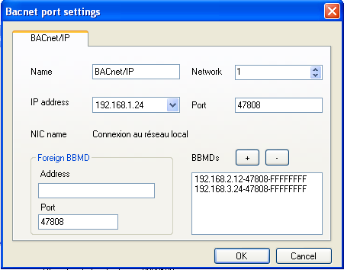
To define the IP of BBMD device connected in another sub-network.
To define a list of IP of BBMD device connected in another sub-network.
BBMD & FDT configuration

Sample of BACnet architecture with BBMD

In the below case, PcVue1 can transmit the identification of devices of the sub-network « Eth2 » to Automate1.

Figure 24 : Example of BBMD architecture

Sample of BACnet architecture with FDT

In the below case, PcVue1 is the only device in the sub-network « Eth1 ».

Figure 25 : Example of FDT architecture

Communication with FDT or BBMD

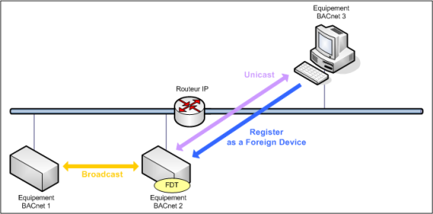

With a standard configuration of network, the Routeur IP filters the broadcast messages sent by all devices. To communicate between two subnets, one device must to identifier at least one device included in the other subnet. For that, the Equipement BACnet 3 must to know the IP address of at least one device of the other subnet, for example the Equipment BACnet 2.

