VERIFICATION PLAN

Vijeo Look V2.0PCVUE 11

OPC communication
with dual network redundancy

Document status | OfficielBETA

 | Department / Function: | Name: | Date:
Writer: | Arc Informatique | Mark CHEN | 08/07
Check: | Arc Informatique | Florent DESPONTIN | 08/07
Check: | Arc Informatique

Update versions
I E | DATE | Redactor
01 | 08/07 | Mark CHEN | First issue

CONTENTS

1. Introduction 4
2. Tests description 4
2.1 Server side endurance tests 5
2.2 Client side failover and endurance tests: 9
3. Tests Result 14

Introduction

We tested OPC redundancy communication with PcVue as redundant OPC server and OPC clients. The third party software MatrikonOPC Redundancy Broker and Tunneller are used in this test(At first, we planned to make this test without using Tunneller, but Broker could not find remote OPC server via DCOM configuration). On the server side we have 20 000 statics variables and 400 variables which change every second by chronometer. 2 PcVue OPC clients subscribe to all these variables, and display 400 changing variables in a mimic.

Tests description

We created four identical virtual machines in four separate host machines, two virtual machines as PcVue OPC redundant server, two as PcVue OPC clients. PcVue version: 11.0_02021.The computers’ information as follow:

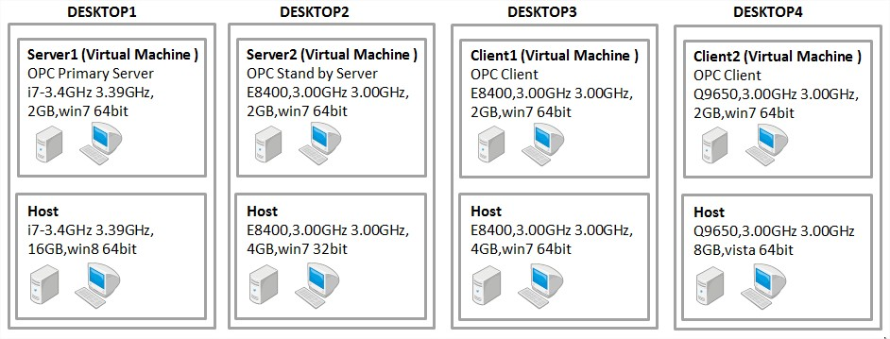
Figure 1

Figure 2 shows the network architecture of this test project.

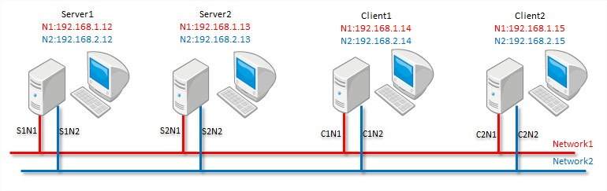
Figure 2

The data flow between server and client is showed in Figure 3.

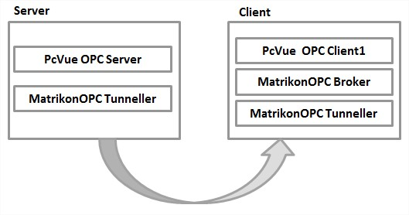
Figure 3

For MatrikonOPC Tunneller and Redundancy Broker configurations, we created three associations. Please refer to KB650 for more details about the configuration parameters.

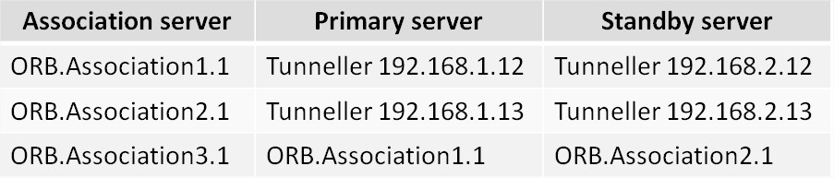
Figure 4

We check the behaviour on server side:
- Sv32.exe Private Bytes
- System flow counter
- Processor activity
- Bandwidth
- Flow smooth

On Client side:
- Failover
- Sv32.exe Private Bytes
- System flow counter
- Processor activity
- Bandwidth
- Flow smooth

Server side endurance tests

For Sv32.exe Private Bytes, we can see in Figure 5 and Figure 6 that the memory usage increases as time goes on. In server 1, time began at 19:00 and end at the next day 06:00, and the memory usage increased roughly from 300MB to 650MB.Server 2 has same problem.

System flow counter of Server 1 is at about 800 event/s, just as we expect (400 variables change every second, subscribed by two clients and sent by the OPC manager). For server 2,Flow counter is 0 because of no clients.
Every 30 minutes the Flow counter drop to 0. This behavior is normal because PcVue creates an Audit.Counters.xxx.txt file every 30 minutes and reset counters at the same time.
Server 1 Sv32.exe Private Bytes and System flow counter：

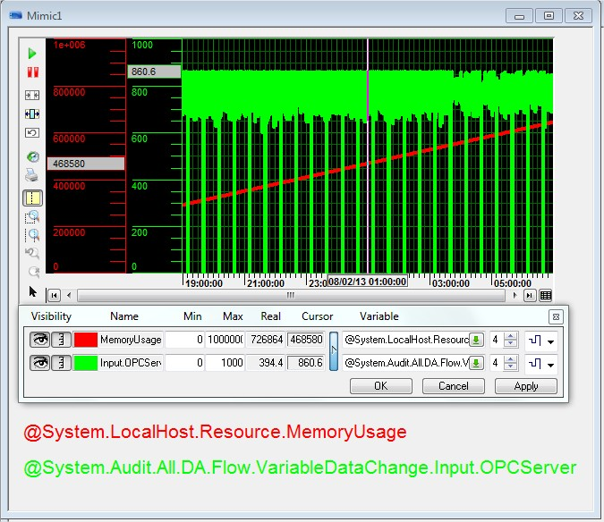
Figure 5
Server2 Sv32.exe Private Bytes and System flow counter：

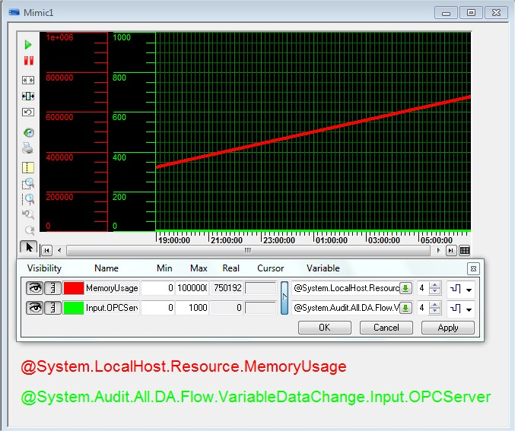
Figure 6

For Processor activity, see screenshot below, the usage is stable. The reason that the CPU usage of Server 1(Primary server) is lower than server 2(Standby server) is that the host of server 1 is better than server 2.

Server1 Processor activity：

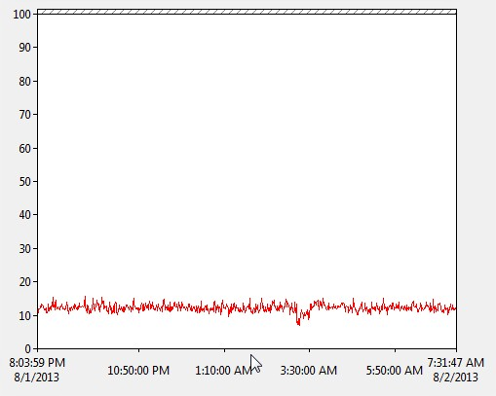
Figure 7
Server 2 Processor activity :

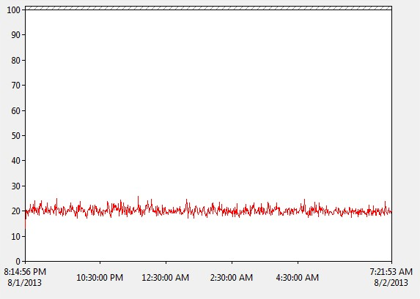
Figure 8

For network bandwidth, the download bandwidth of server 1 is about 800 bytes/s and upload bandwidth is about 24KB/s, please refer to Figure 9.For server 2,as it is a standby server and no clients subscribe on it, incoming and outgoing bandwidth are small.

Server1 Bandwidth:

Figure 9

Server 2 Bandwidth:

Figure 10
For Flow smooth, no test in server side.

Client side failover and endurance tests:

For failover test, We tested one and two clients individually connecting to OPC server in the mode of Warm and Cold. The correct step we expect is that when all networks are in good state, the work channel is S1N1.When S1N1 is disconnected,S1N2 will become work channel. When S1N1 and S1N2 are disconnected,S2N1will work. When S1N1,S1N2 and S2N1 are disconnected,S2N2 will work.
When S1N2,S2N1 and S2N2 is disconnected,S1N1 will work. When C1N1 is disconnected,C1N2 will work. When server 1 crash, server 2 will work.
The failover we tested is as Figure 11. At first, we disconnect each network step by step, then we check failovers and delays. We can see the worst-case failover delay we tested in the table below.
But be careful, if Server or Client CPU usage is too high(e.g. exceed 90% for more than 10 seconds),the client may lose its’ connection to OPC server and its data refresh, or only the connection status in Broker becomes unstable.
For the case that high CPU usage will cause disconnection ,we made two other tests to verify this issue .
First we created a new test project with 20 000 variables that change every second with KEPServer OPC server and OPC quick clients subscribes all variables in this test platform. We found that the connections between client and server and failover were very good. All CPU usages were in a low level. We think that standard OPC server and OPC client are ‘light’ software, they cost lower system resource. We also created a new test project of PcVue server and client with just 2 variables, we found that the failover and connection were also very good. All CPU usages were in a low level. So if you want to ensure connection and failover in a good state, you must control your system resource in a lower level.

One Client, Redundancy Mode: Warm/Cold(Please refer to Figure 2 and Figure 11)
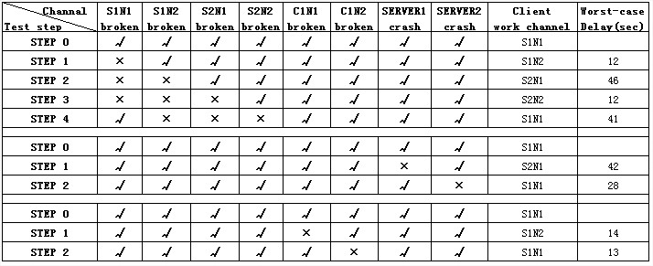
Figure 11
Two Clients, Redundancy Mode: Warm/Cold(Please refer to Figure 2 and Figure 12)
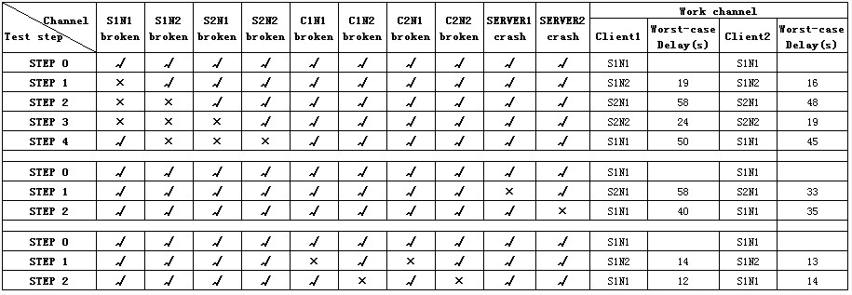
Figure 12

For Sv32 Private Bytes, we can see in Figure 13 and Figure 14 that the memory usage increases just as server side.

System flow counter is at about 400 event/s,just as we expect(400 variables change every second and are received by Varmanager from server side).
Every 30 minutes the Flow counter drop to 0. This behavior is normal because PcVue create an Audit.Counters.xxx.txt file every 30 minutes and reset counters at the same time.

Client 1 Sv32.exe Private Bytes and System flow counter：

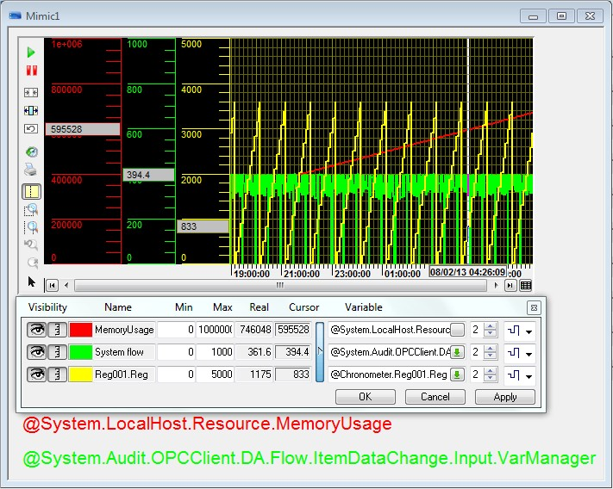
Figure 13
Client 2 Sv32.exe Private Bytes and System flow counter：

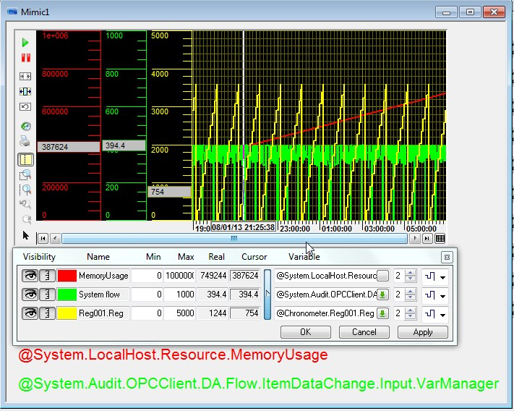
Figure 14

For Processor activity, see screenshot below, the usage is stable.

Client 1 Processor activity：

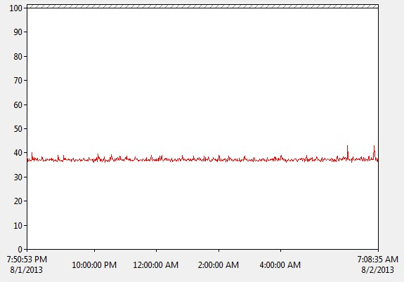
Figure 15

Client 2 Processor activity:

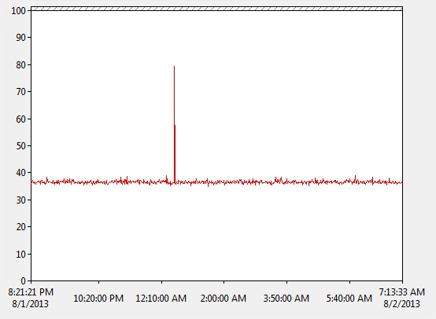
Figure 16

For network bandwidth, the download bandwidth is at about 12 KB/s and upload bandwidth is at about 400 Bytes/s ,please refer to Figure 17 and Figure 18.

Client 1 Bandwidth:

Figure 17
Client 2 Bandwidth:

Figure 18

For Flow smooth,we create 400 variables in a mimic,and all of them can refresh smoothly.

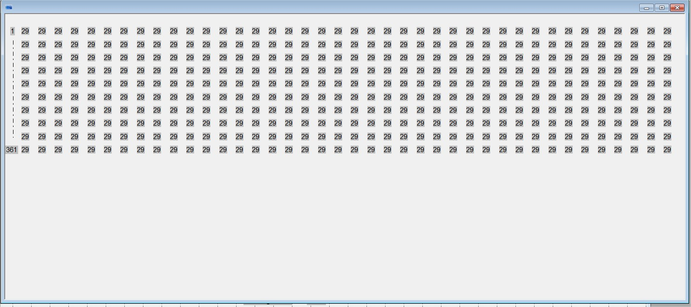
Figure 19

Tests Result

According to the tests above, we can have the following conclusions,

Failover

The failover is good if the CPU usage is not in a high level, if not, failover will fail.

Sv32 Private Bytes

There is a memory leak because this counter increase constantly, we had added a SPR (number 48475) for this issue. After fix we will redo this test.

System flow counter

This test result is just as expected, no problem for this.

Processor activity

The CPU usage is stable, but not in a low level. Because the virtual machines are not based on a very powerful host and PcVue projects are big. We also have a big problem that PcVue project costs so high CPU usage. But KEPServer OPC has no this issue even if it has 20 000 variables that change every second.

Bandwidth

In server side, the outgoing and incoming bandwidths are about 22KB/s and 800 bytes/s with
400 variables refreshing every second ,and in client side, they are about 800 bytes/s and 22KB/s.
So no problem for this test.

Flow smooth

In client side, we create 400 variables in a mimic, and they can refresh smoothly.

Besides, we found an anomaly:

we created a new project just with 1000 variables that change every second by chronometer and displayed them in a opened mimic, then it may cause a 100% CPU usage, I have created a SPR(number 48572) for this issue.

When you do OPC mapping (OPC server is also PcVue and we use MatrikonOPC Tunneller),you cannot see the server side variables(if OPC server is third party OPC server like Kepware, this can work),so you have to write variable information directly to Item Id area or use Application Architect to finish mapping. I have created a SPR(number 48573) for this issue.

