Table des matières
1 - Remote Desktop Services setup 2
2 – How to install the Remote Desktop Services 3
The Quick Start Scenario 5
The Standard Deployment Scenario 5
Creating a collection 9
Collection parameters 10
3 - The Remote Desktop Management Console 13
Presentation 13
The servers view 14
The collections view 16
Deployment parameters 17
4 – Deploy applications with (or without) RemoteApp 23
1 – With RemoteApp 23
2 – Without remoteapp 26
5 – The Group Policy: the basics 26
Group Policy: How can I access the Group Policy Editor? 27
6 – The Remote Desktop Services Licensing manager 29
Installing the RDLM 30
Installing the licenses 30
7 – The unofficial way: Doing it without an Active Directory Domain 31
8 – Glossary 32
RD Session Host : 32
RD Connection Broker: 32
RD Gateway: 32
RD Web Access: 32
RD Licensing : 32

1 - Remote Desktop Services setup
Windows Server 2012 and 2012 R2 introduce a new concept for Remote Desktop Services setup: the Remote Desktop Services installation is a scenario, making the setup of all the services needed by Remote Desktop Services on one or more servers. This installation mode installs and configure also the Remote Desktop Management Services (RDMS), giving access to the new management IHM (RDM). The RD session host Role, RD Web access Role and RD Session Broker Role are installed by this way.
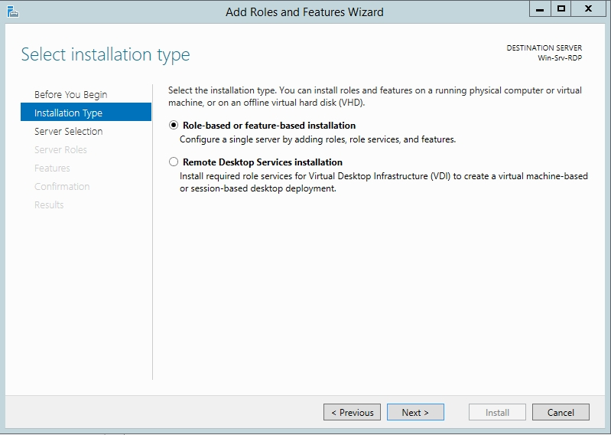
It’s still possible to use the role-based or feature-based Installation, but as the classical tsadmin.msc (Terminal Services manager console on Windows Server 2008 R2 and above) [screenshot] and tsconfig.msc (Terminal Services Configuration console on Windows Server 2008 R2 and above) [screenshot] don’t exists anymore on Windows Server 2012, all configuration and management of the Remote Desktop Role is to be done via Group Policy Objects or Registry.
Note that, according to Microsoft, two prerequisites are mandatory on a Windows Server 2012 or 2012 R2 in order to install Remote Desktop Services:
- All the servers involved in the Remote Desktop Role must have a fixed IP address
- All the servers involved in the Remote Desktop Role must be members of an Active Directory Domain
Of course, you have to be logged with an account with Administrator rights on the servers in order to install all the Roles needed by the Remote Desktop Services Role.

2 – How to install the Remote Desktop Services
On the server, open the Server Manager, click on Manage, then Add Roles and Features
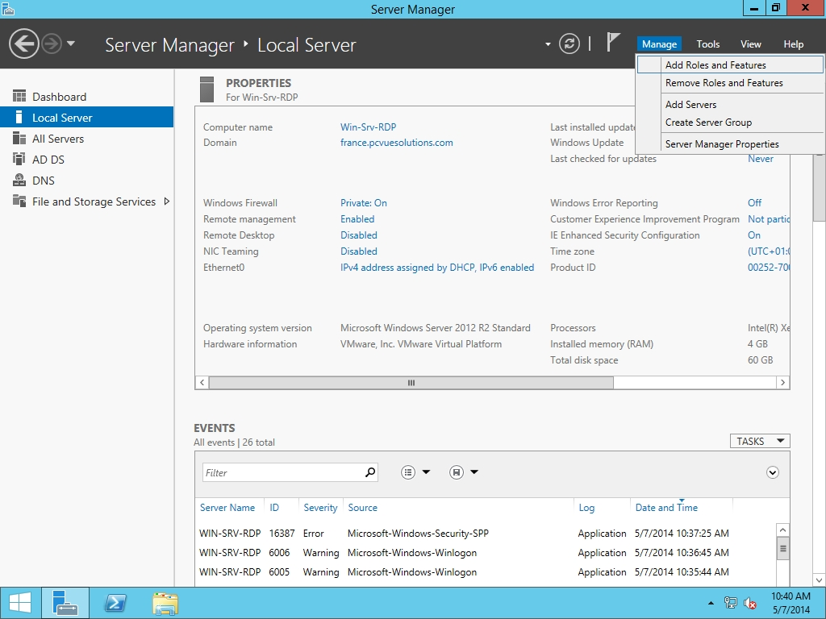
The Add Roles and Features Wizard opens. Choose Remote Desktop Services installation.
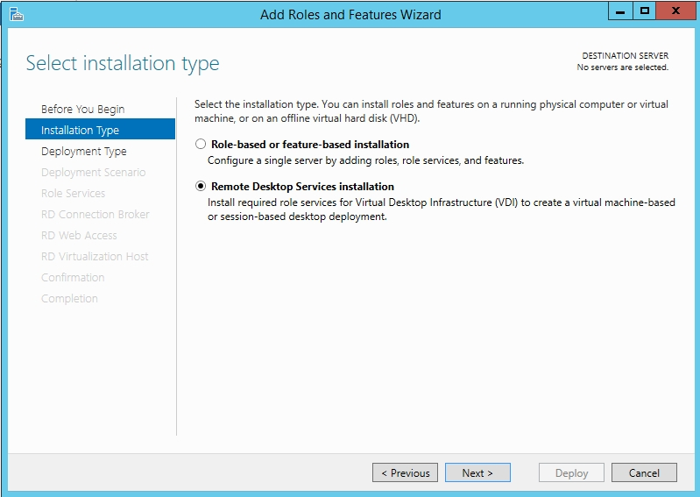
If your server is not a member of an Active Directory Domain, you will be prompted:
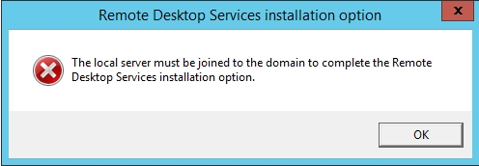
Otherwise, you have to choose between Standard Deployment, or a quick Start Scenario
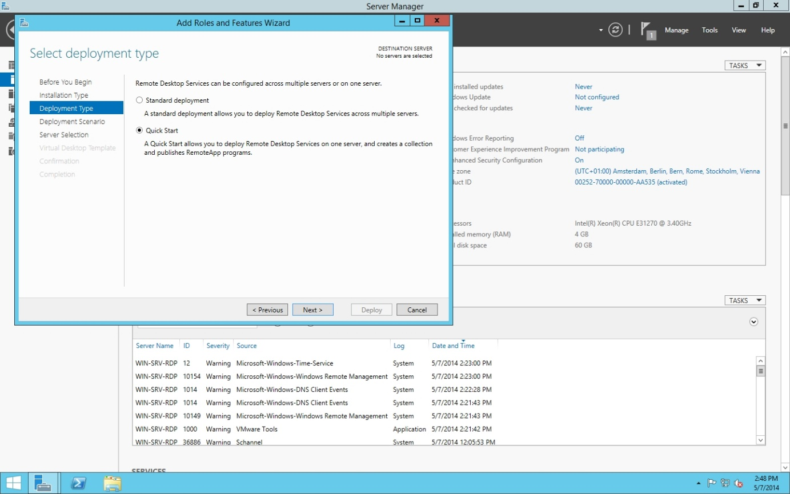

The Quick Start Scenario
For lab or testing purpose, you can use the quick start scenario, which installs and configure all roles and services needed by the Remote Desktop on one server (RD Connection Broker, RD Web access and RD Session Host). It also installs and configures the Remote Desktop Management Service, giving access to the Remote Desktop Management Console, and creates a Remote Desktop Service Collection, named QuickSessionCollection. Note that three apps are published as RemoteApp by default in this scenario: Calc, Paint and Wordpad.
That’s pretty good, but in the other hand, it adds the AD group “Domain users” to the “Remote Desktop users” group, and can seriously be dangerous in security-minded production cases. So never use it in production

The Standard Deployment Scenario
Note: this is to be considered as the “standard” way
So let’s back to the Server Manager, and the Add Roles and Features Wizard. As previously, Select “Remote Desktop Services Installation”. Click on Next.

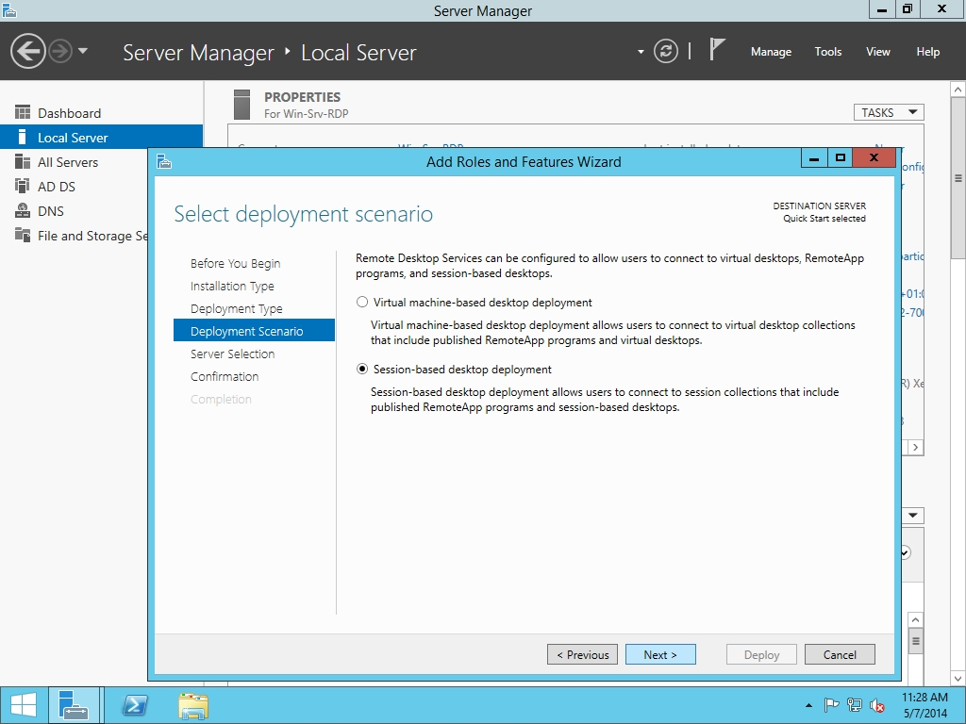
You have to choose between Virtual machine-based desktop deployment, which is out of our scope, and session-based desktop deployment.
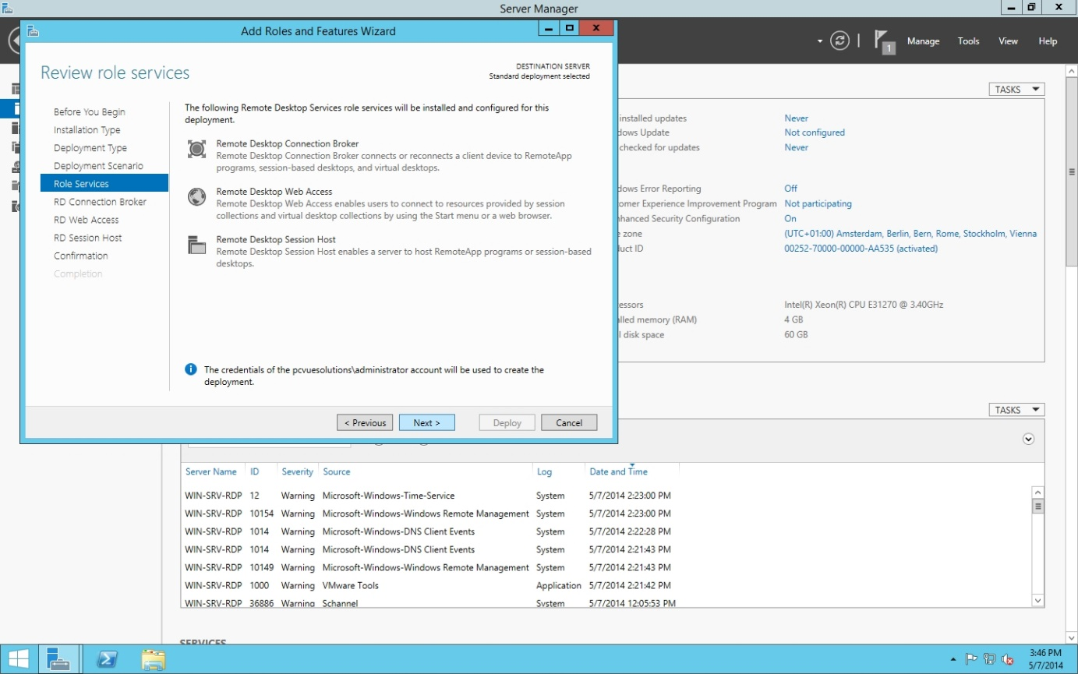
The wizard presents the Roles that will be installed and configured. Click on Next.
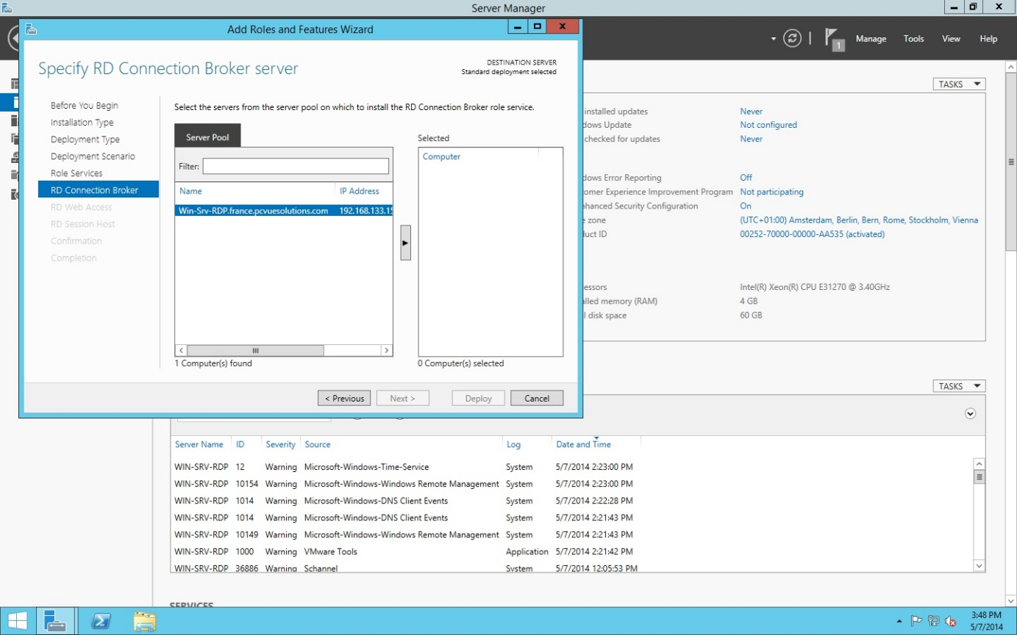
You have to select on which server you want the RD Connection Broker Service.
Note: if the server on which you want to install the role is not shown, you have to cancel the wizard, click on “manage” in server manager, and add the server(s).
After that, click on Next.
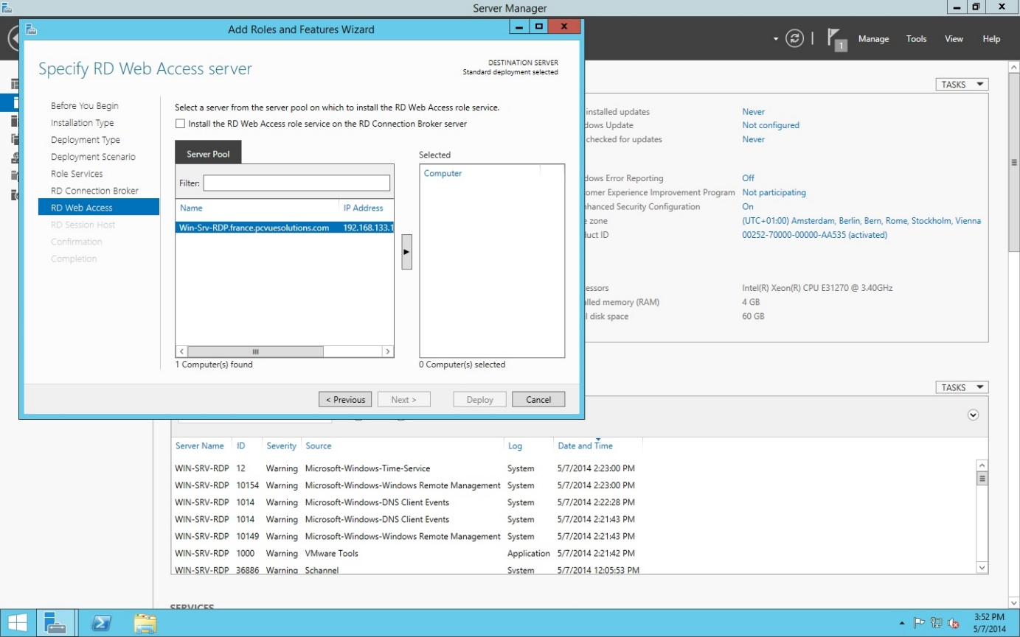
Here you have to select on which server you want the Remote Desktop Web Access Role (mandatory !).
Note you have a checkbox if you want to install this Role on the same server that hosts the RD connection Broker Role. Click on Next.
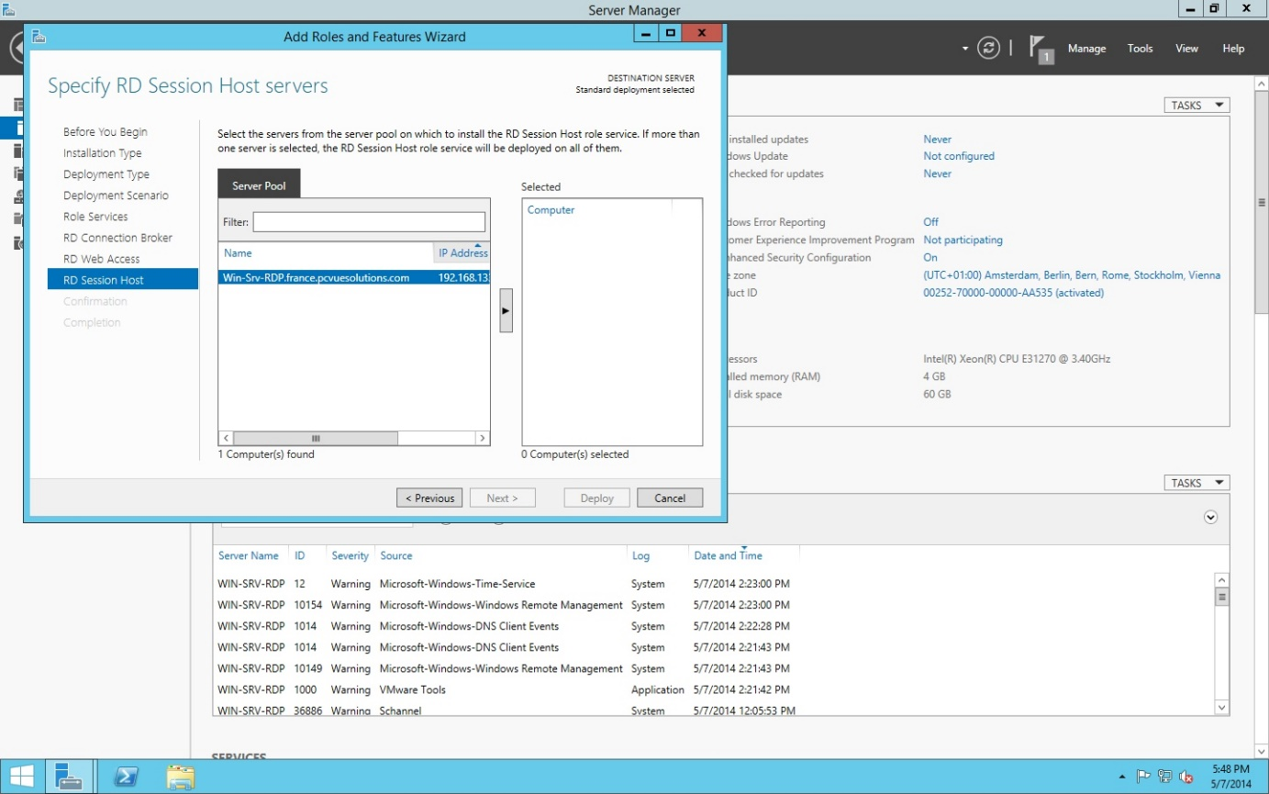
As previously, you have to select the server(s) which will host the RD Session Role. Click on Next.
A confirmation screen is now shown
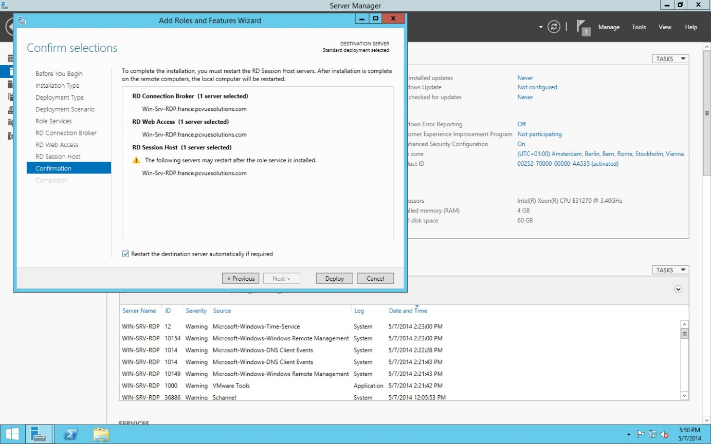
You just have to tick the “restart automatically” checkbox, and click on “Deploy”.
The server then reboots. You have to log on with the same account you have used to initiate the deployment.
The server Manager opens automatically, and shows the progression of the desired features. When finished, you will have the following screen
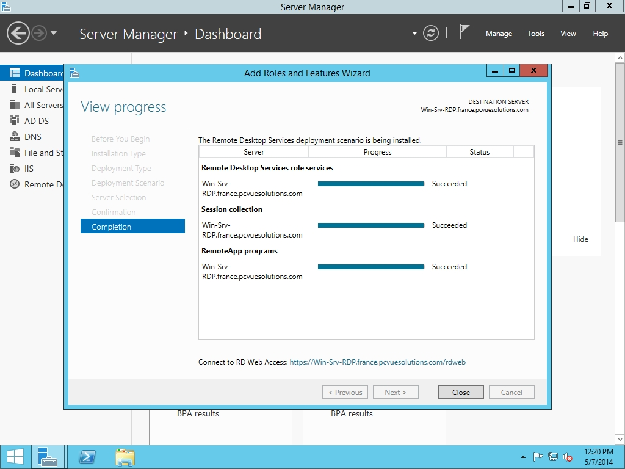
Click on “Close”, and go back to Server Manager.
Note : A notification appears on the taskbar about licensing. The Remote Desktop Services will work 120 days without License. We will see further in this document how to setup and configure a license server.
You can see in the server manager that:
- The three Roles are installed on the specified servers
- There’s no collection defined, unlike in the QuickStart scenario. It means only Domain Administrators can connect to the RD Session Host(s). You have to define by yourself a collection in order to make connections by other users available
- There’s no apps published by RemoteApp.

Creating a collection

Note: A single collection can be shared among several RD Host Servers, all sharing by this way all collection parameters.
Note 2: You can define only one collection by RD Host in your infrastructure.
In the Collection view, click on “tasks” and choose “create a new collection”

Collection parameters
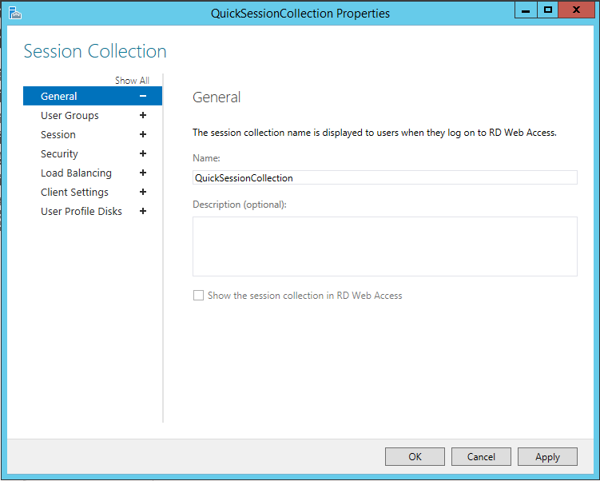
The name, a description, and NOTE the checkbox “Show the session collection in RD web access”
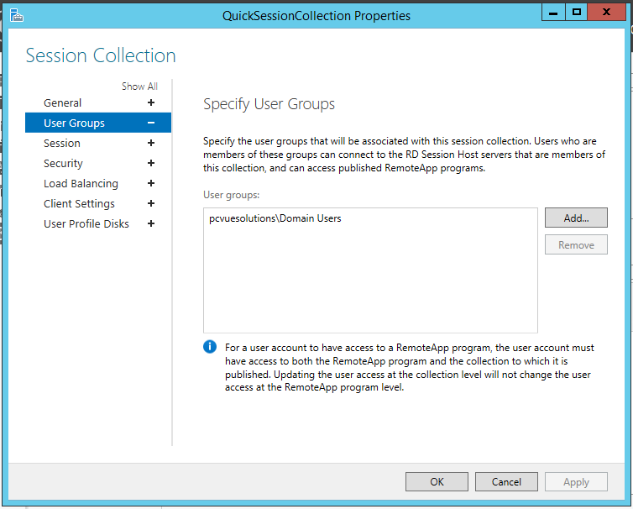
You have to select the user group(s) allowed to connect through Remote Desktop. Note you cannot select here the classical “remote desktop users”, as it’s no longer a user group, but a security group. So you have to go back to the server manager, and create a new AD domain group. After that, you will add the designated AD domain group in this screen.
Never let or use the domain users group here, Always ask your customer about its security policy. If there’s no security policy, always create a specific group for this purpose
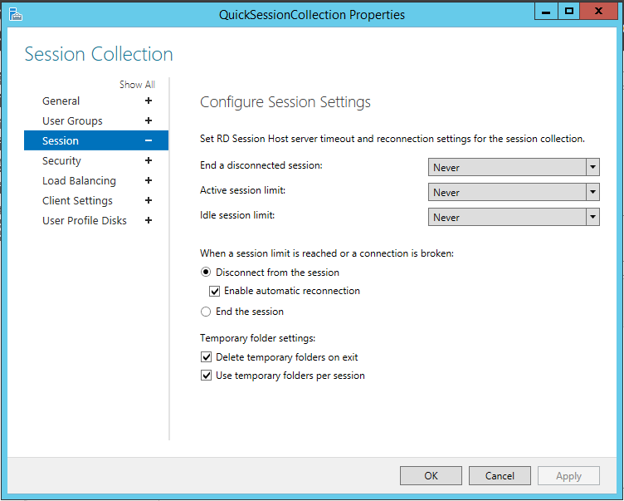
The session parameters. One by one:
- End a disconnected session: close all disconnected sessions. Suggestion: 2 hours (?)
- Active session limit: maximum length of an active session, to prevent memory leaks when a user never ends his session. Suggestion: 12 hours (?)
- Idle session limit: close all sessions connected without user input. Suggestion: 4 hours (?)
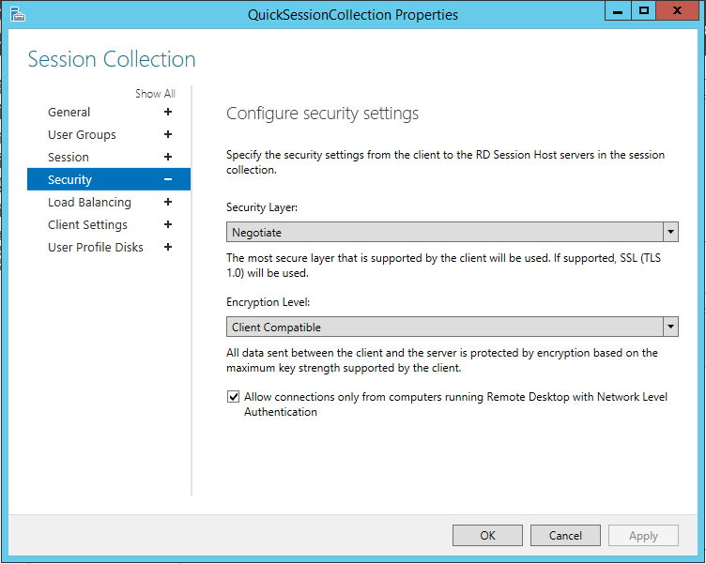
The security settings. Note the “Allow connections only from…”, which can be uncheck if old RDP clients are needed by the customer. Never uncheck it unnecessarily
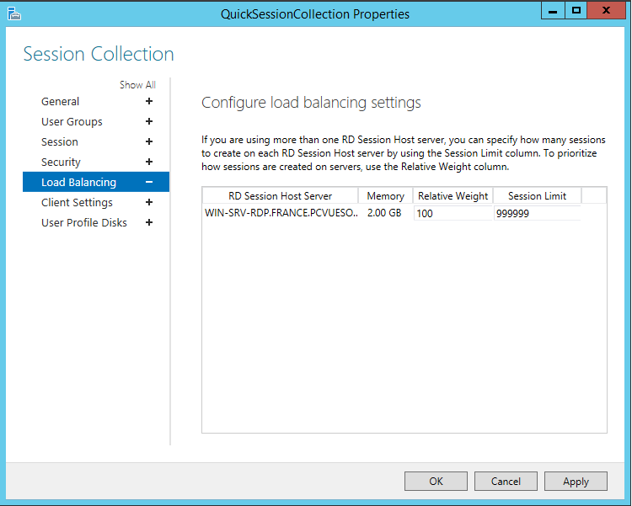
If there’s more than one RD Session Host, you can configure here their relative weight, and the session limit on each, making load-balancing on the servers

3 - The Remote Desktop Management Console

Presentation
In a Windows Server 2012 Remote Desktop environment, most configuration or administrative tasks are to be done with the brand new Remote Desktop Management Services
As we have seen in the setup part, by default a Remote Desktop Infrastructure in Windows Server 2012 is composed at minimum by three roles:
- RD Connection Broker, which manages the RDS infrastructure, user connections, and network load balancing. This role is the central part of all the RD infrastructure, even if you have only one RD Server.
- RD Web Access, Which presents to Remote Desktop Users a Web Portal in order to give access to published apps (or desktops)
- RD Session Host, which host and manage sessions initiated by Remote Desktop Users
A RD Licensing server is mandatory for the infrastructure to work (after the initial grace period), but can be hosted on a separate server, as it can be shared among several RD servers
In order to access the new RDMS console you have to open the Server Manager
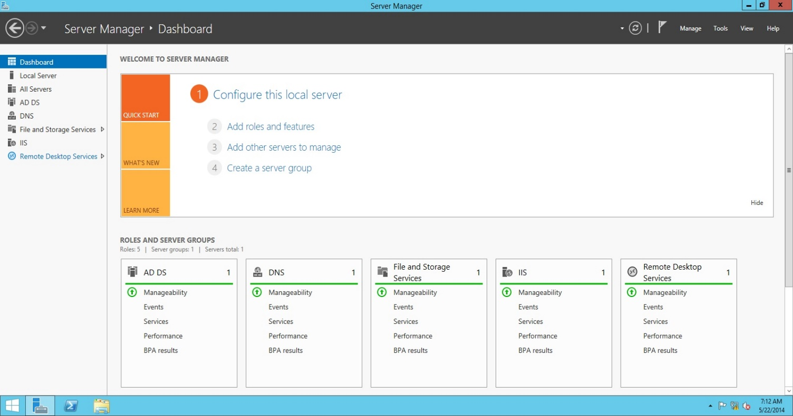
In this screenshot, the RDMS console is the last in the left menu. Click on it.
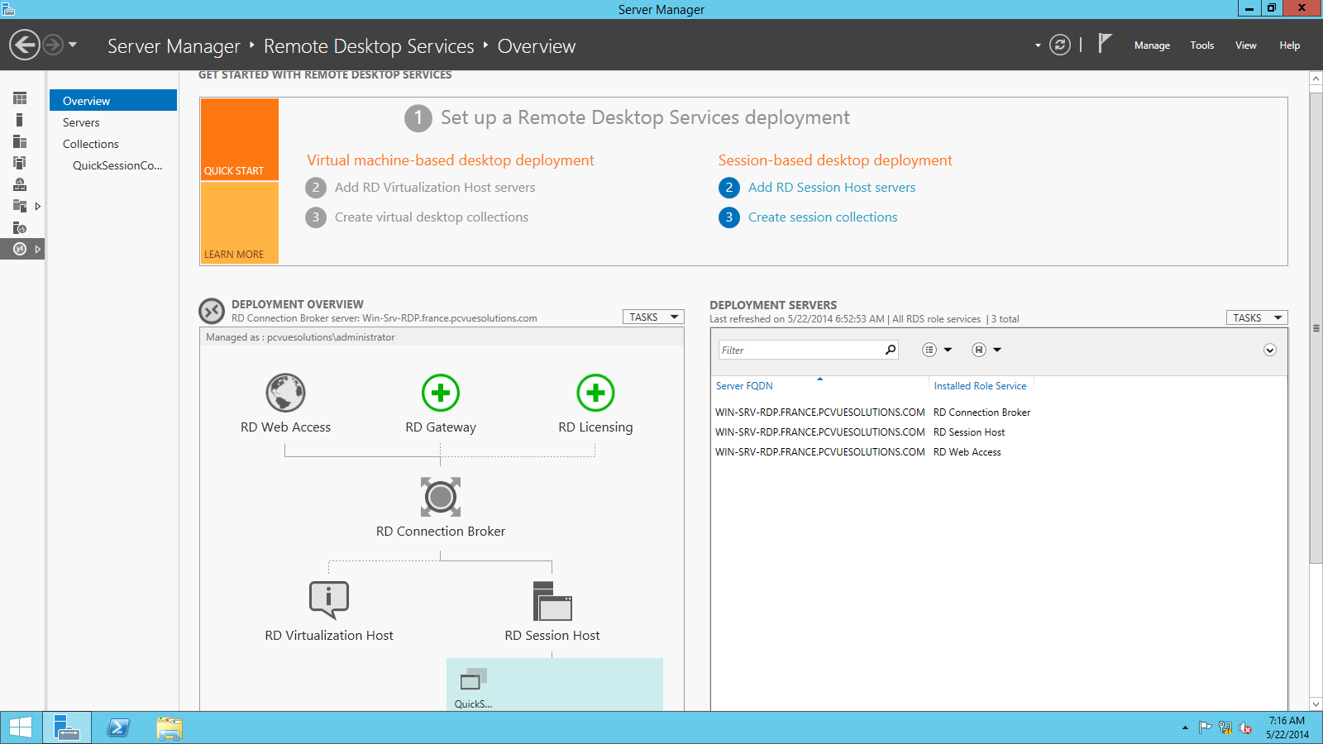
This overview presents the RD infrastructure state. Here in the lower part we can see both RD Web access, RD session host and RD connection broker are configured, and the servers involved in the infrastructure (in the right part).

The servers view

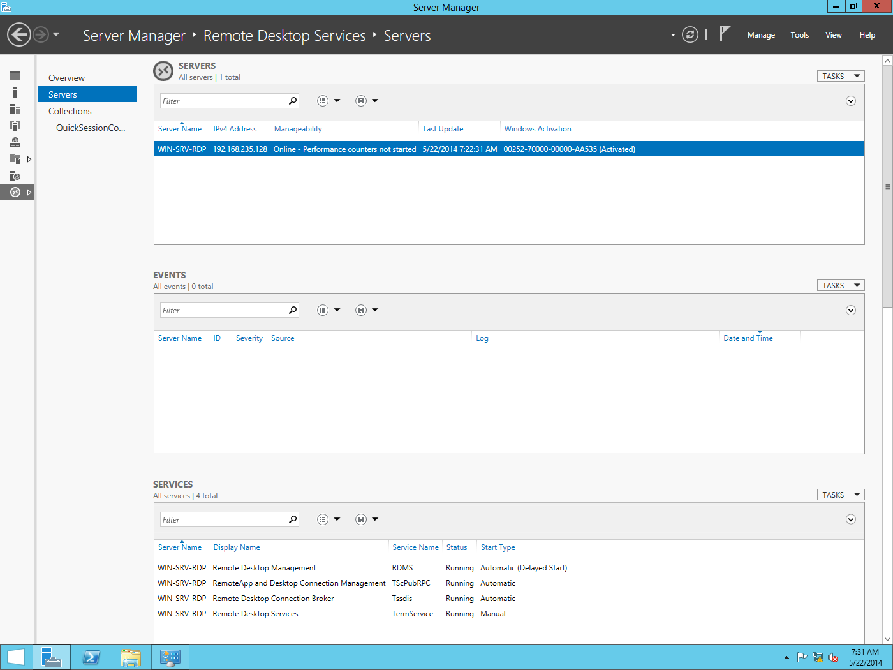
In this section you can see and manage all servers in your RD infrastructure. Here you can add Roles and features to them (just click on “task” in the servers section), and collect Events.
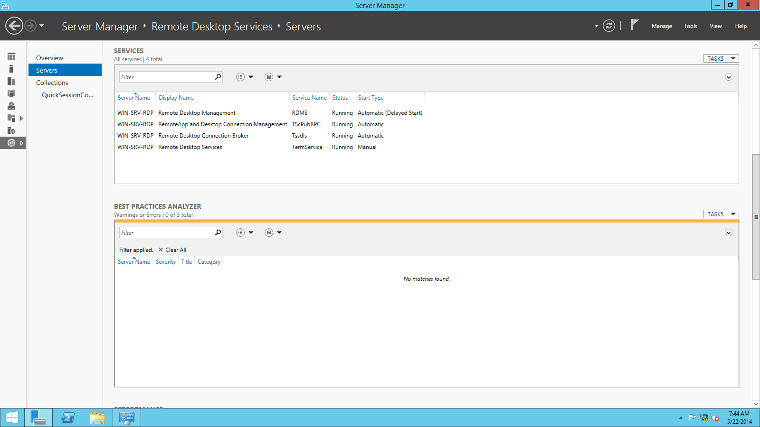
Navigating lower in the same section, we can see all services involved in the RD infrastructure, with their localization and state.
Then, and typically in modern Microsoft Management, you find a Best Practice Analyzer”, that I strongly recommend to run when all your RD infrastructure will be configured. To do this, just click on the “task” button in the top right part, and click on “start BPA scan”
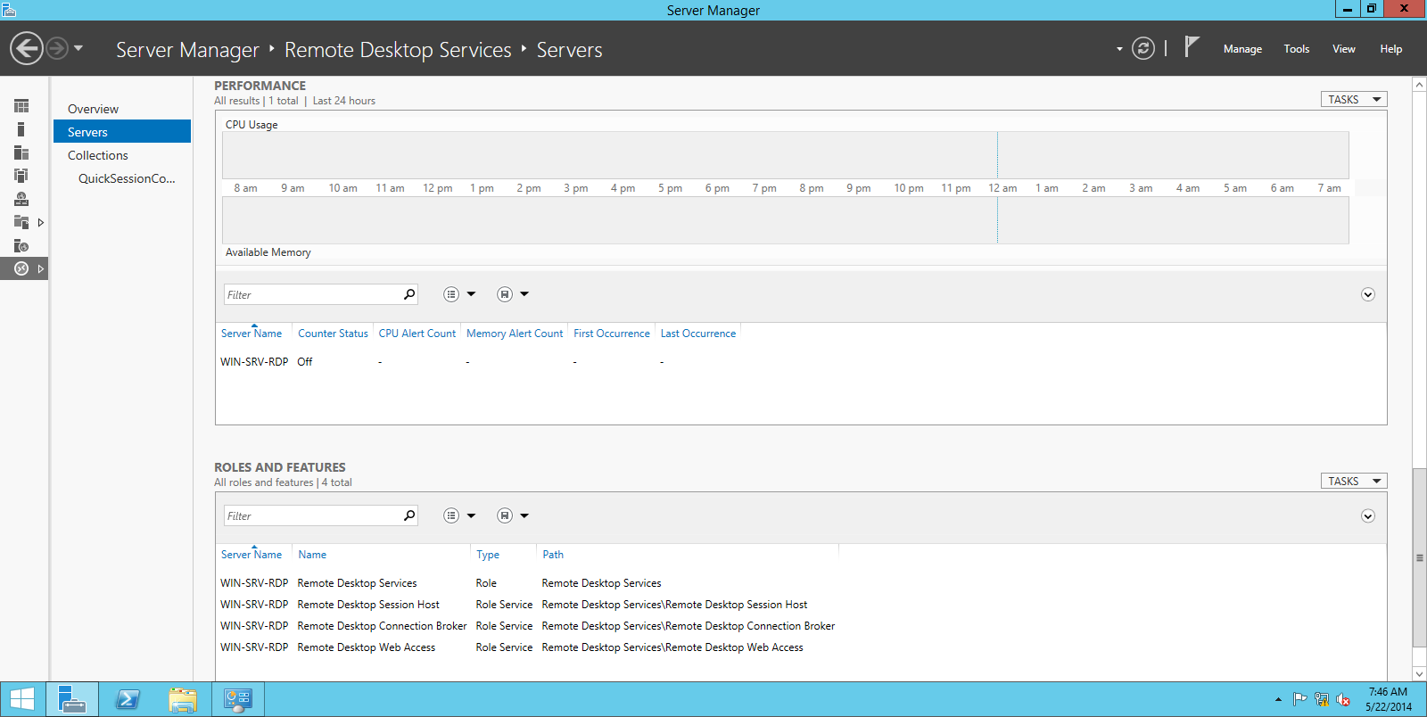
In the lower part of this section, you’ll find the performance counters, which can be very useful if your RD infrastructure suffers of poor performances, and a Roles and Features view showing on which server(s) they are installed

The collections view
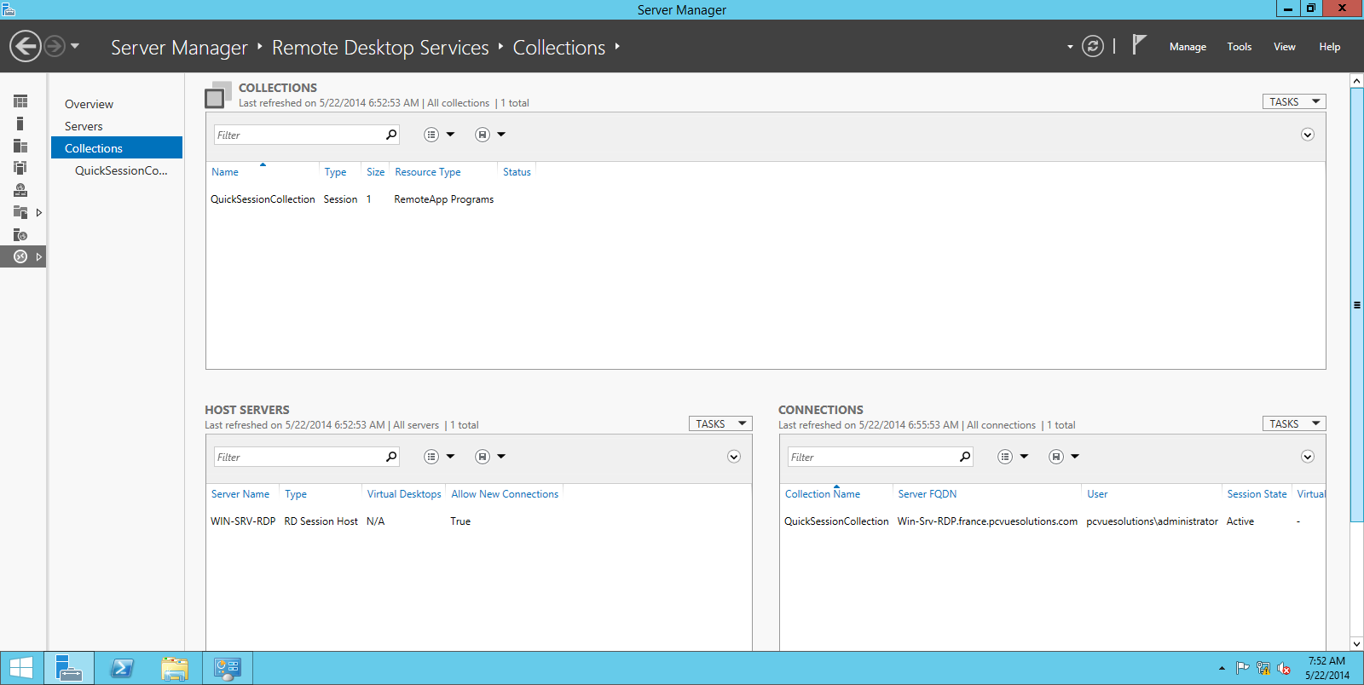
In this section you can see all collections defined in the RD infrastructure. Here you can manage (with the task button) the deployment parameters like authentication method used, licensing mode, certificates, and so on. Just click on “edit deployment parameters” on the task button in the upper right.

Deployment parameters
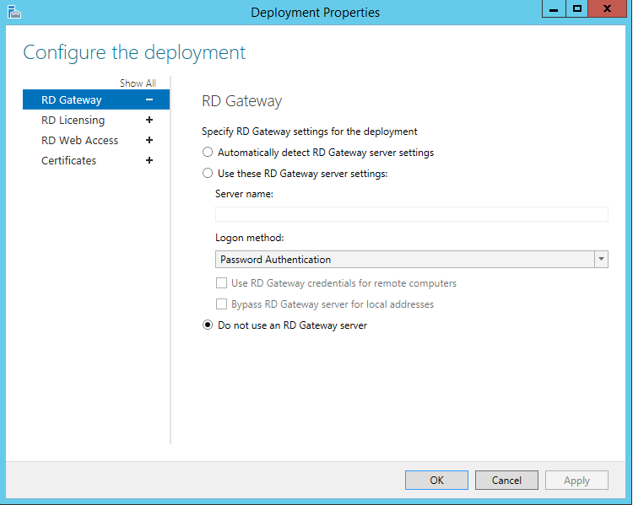
You can specify a RD gateway server, in order to give access from the web. Beware of multiple security issues!!!

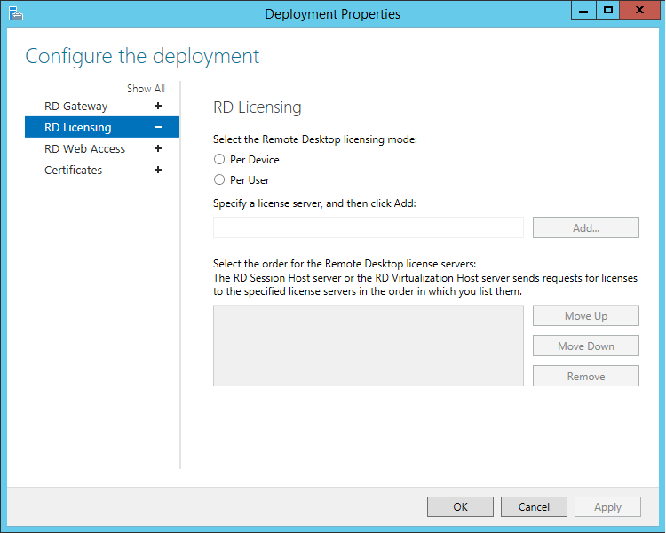
The licensing parameters: you have to select both the Remote licensing mode, and the license server

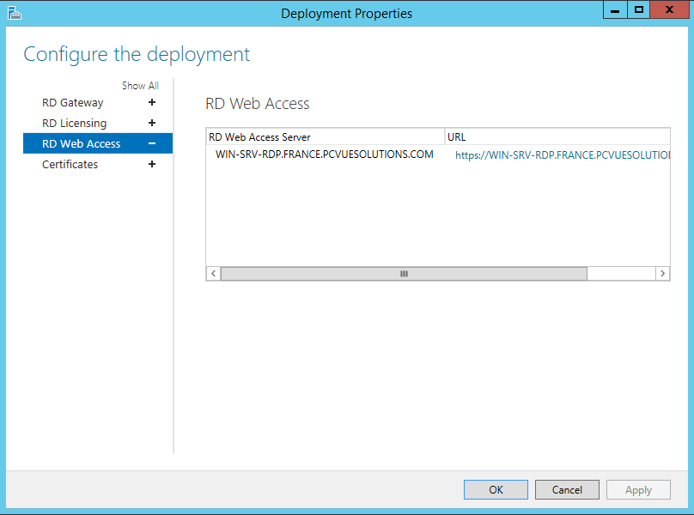
You can find here the URL for web access. Note you cannot modify it

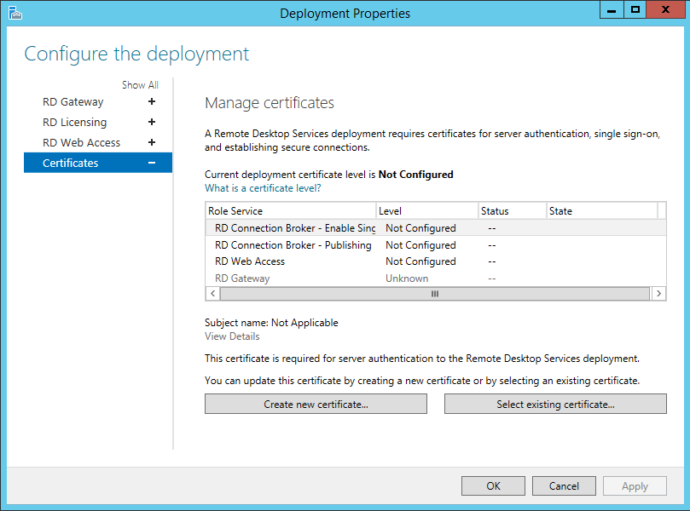
A must see, but requires another document
Returning to the collection view, in the lower right part you can manage users or devices connections to the collection. You can close the sessions, force disconnection, or send a message here.
Note 1: A Remote Desktop Session Host can belong to only one collection, but a single collection can contain many RD Session hosts, sharing the same session parameters, security parameters, and so on.
Note 2: The so-called QuickSessionConnection is useful for lab testing, but not for production, as we could see furthermore. It’s only used in this doc to show the screenshots, and beware of it. The first thing you have to do in production scenario is to delete it, and recreate a new one
Here’s the QuickSessionCollection screenshot:
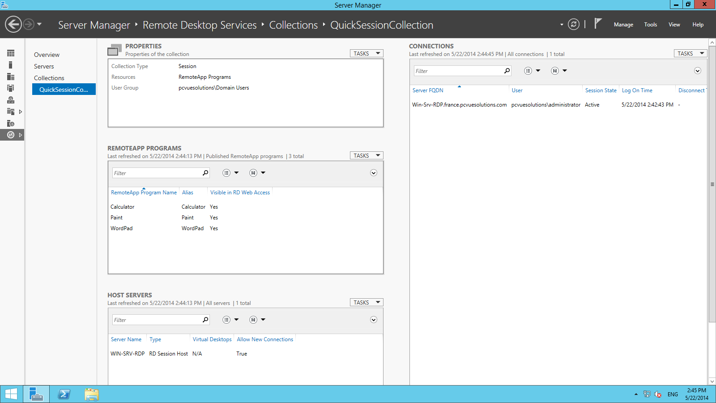

In the upper left part, you can define the collection properties.
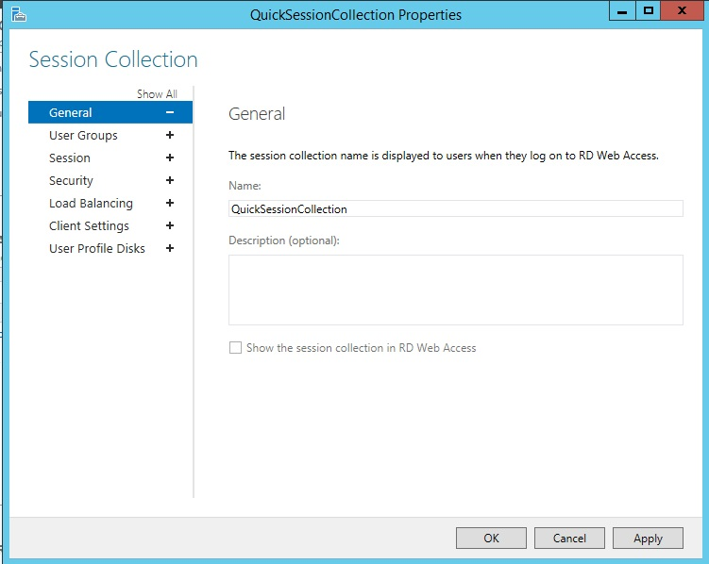
Two parameters here: the name of the collection, and the very important checkbox “Show the session collection in RD Web Access”, which is here grayed out because there’s already three remoteApps published.
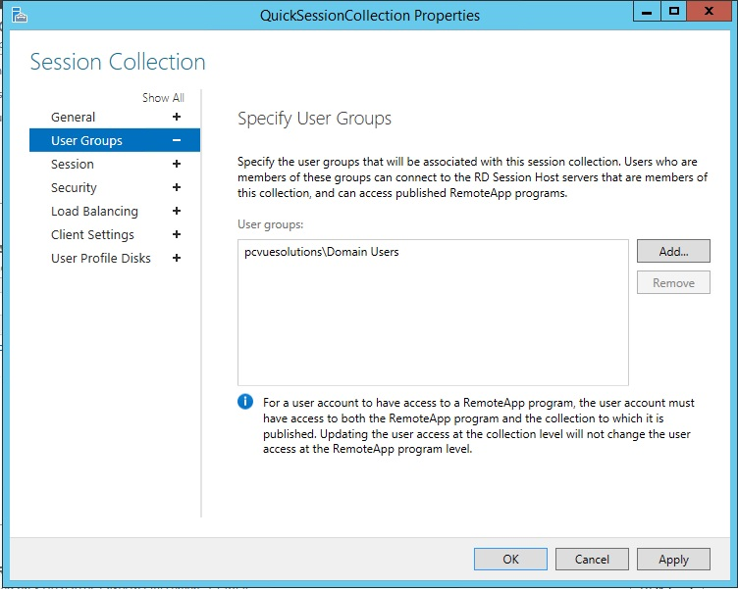
Here you specify the user groups that will have access to this collection. Note in the above screenshot, the big security issue introduced by the Quickstart scenario
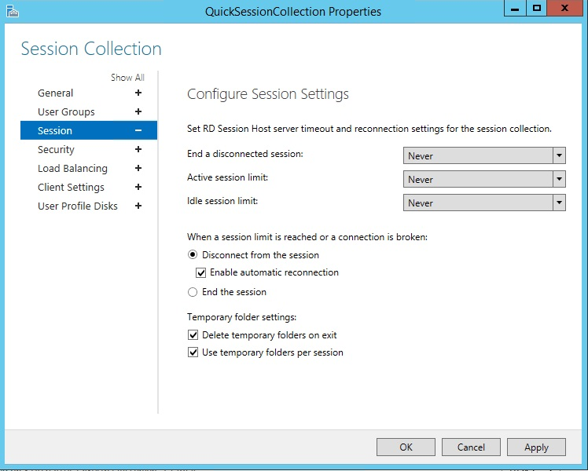
Here are the session settings parameters (see page 11)
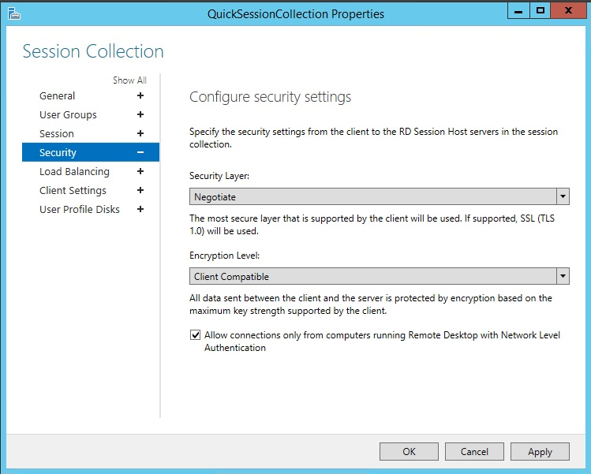
The “Allow connections only from…” can be unchecked if old RDP clients are needed by the customer. Never uncheck it unnecessarily
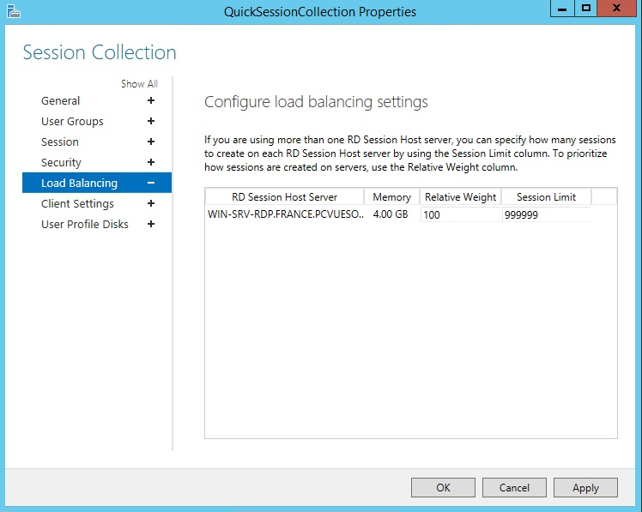
Here you can configure load balancing between different RD Hosts Servers

4 – Deploy applications with (or without) RemoteApp

1 – With RemoteApp
Assuming you have a working collection defined on your RD Host, go to the server manager / Remote Desktop Services / Collections view, and select the collection in which you want to publish pcvue as a remoteapp.
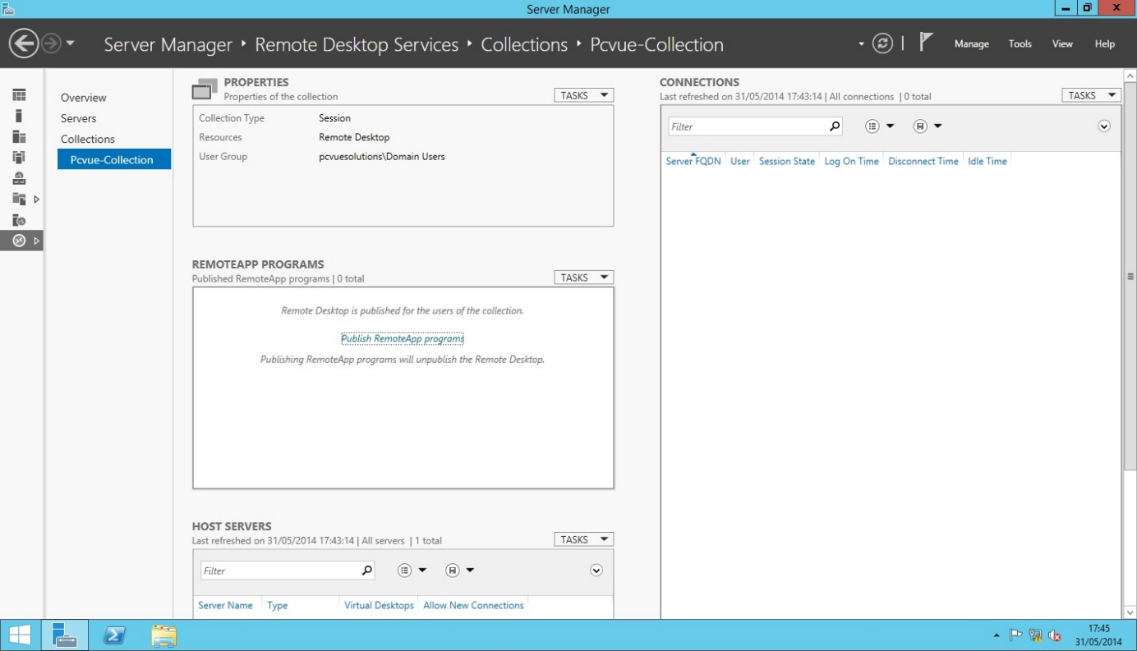
Click on “publish remoteapp programs” in the corresponding section. A wizard showing all available installed programs opens
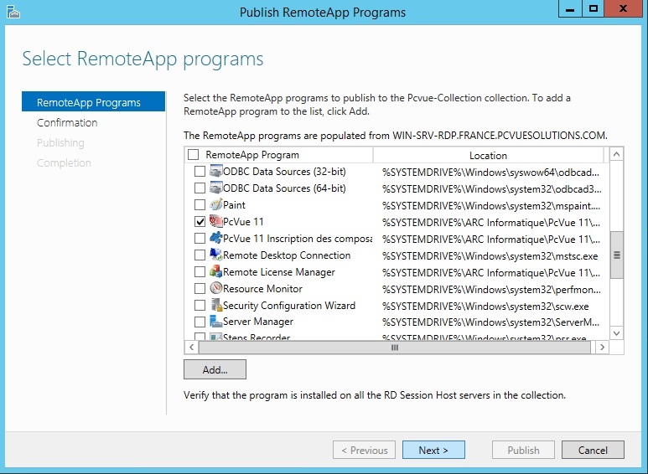
Click on “next” to confirm your selection, and “publish” to complete the procedure. After a short time, you can see your new remoteapp program in the server manager
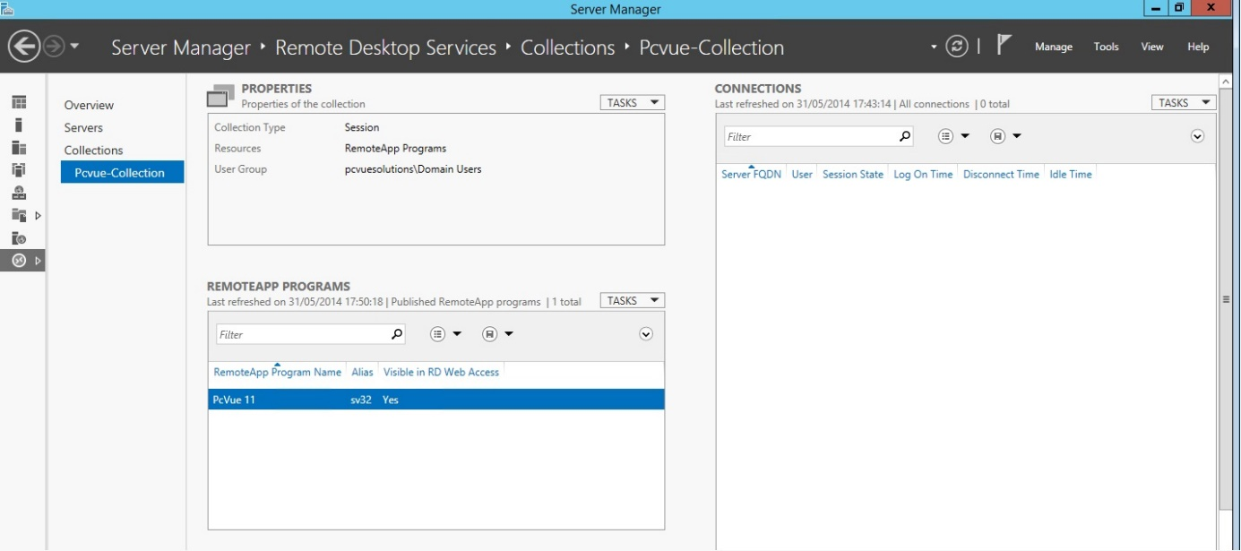
Right- Click on “pcvue 11”, /edit properties
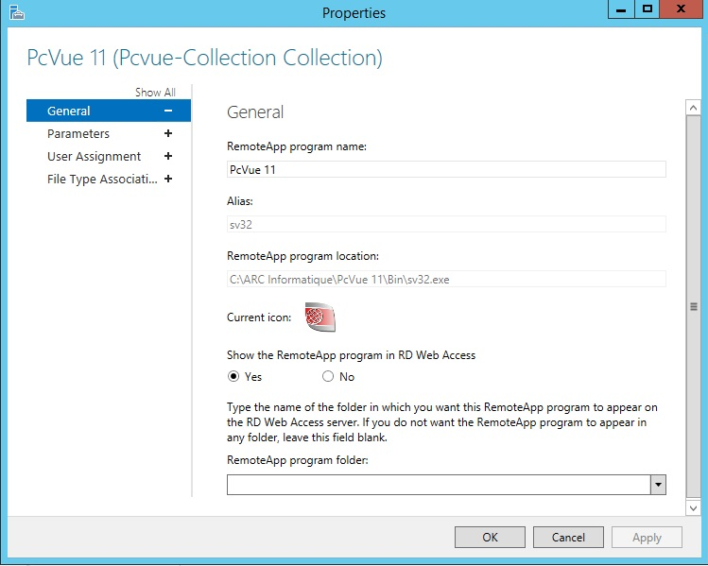
Note you can hide PcVue from RD Web Access here
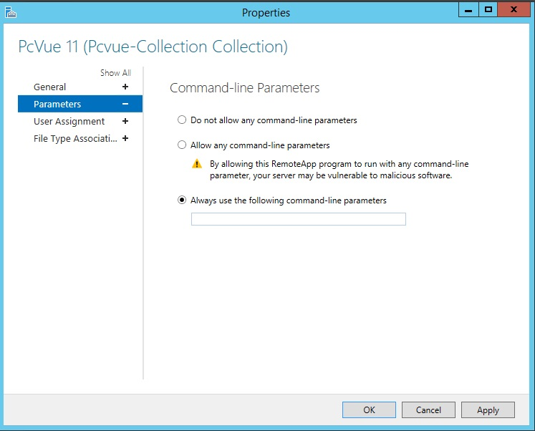
Here are the so important command-line parameters for our favorite software
Note : The “user assignment” can be used to define more precisely who can access the published software. By default this parameter is inherited from the collection’s corresponding parameter

The published remoteapps are reachable via a compatible web browser on https://[your.remote.desktop.session.broker]/RdWeb

2 – Without remoteapp
The same functionality can be achieved through Group Policy (see the corresponding chapter). The setting can be found in Computer Configuration->Administrative Templates->Windows Components->Remote Desktop Services->Remote Desktop Session Host->Remote Session Environment.
You can no longer publish .rdp nor .msi files in Windows Server 2012. But rdp files are still supported.

5 – The Group Policy: the basics

Wikipedia says:
Group Policy, in part, controls what users can and cannot do on a computer system, for example: to enforce a password complexity policy that prevents users from choosing an overly simple password, to allow or prevent unidentified users from remote computers to connect to a network share, to block access to the Windows Task Manager or to restrict access to certain folders. A set of such configurations is called a Group Policy Object (GPO).
To accomplish the goal of central management of a group of computers, machines should receive and enforce GPOs. A GPO that resides on a single machine only applies to that computer. To apply a GPO to a group of computers, Group Policy relies on Active Directory for distribution. Active Directory can distribute GPOs to computers which belong to a Windows domain.
Since Windows XP, users can manually initiate a refresh of the group policy by using the gpupdate command from an elevated command prompt.
Group Policy Objects are processed in the following order (from top to bottom):
- Local - Any settings in the computer's local policy. Prior to Windows Vista, there was only one local group policy stored per computer. Windows Vista and later Windows versions allow individual group policies per user accounts.
- Site - Any Group Policies associated with the Active Directory site in which the computer resides. (An Active Directory site is a logical grouping of computers, intended to facilitate management of those computers based on their physical proximity.) If multiple policies are linked to a site, they are processed in the order set by the administrator.
- Domain - Any Group Policies associated with the Windows domain in which the computer resides. If multiple policies are linked to a domain, they are processed in the order set by the administrator.
- Organizational Unit - Group policies assigned to the Active Directory organizational unit (OU) in which the computer or user are placed. (OUs are logical units that help organizing and managing a group of users, computers or other Active Directory objects.) If multiple policies are linked to an OU, they are processed in the order set by the administrator.
The resulting Group Policy settings applied to a given computer or user are known as the Resultant Set of Policy (RSoP). RSoP information may be displayed for both computers and users using the gpresult command from an elevated prompt
Inheritance
A policy setting inside a hierarchical structure is ordinarily passed from parent to children, and from children to grandchildren, and so forth. This is termed inheritance. It can be blocked or enforced to control what policies are applied at each level. If a higher level administrator (enterprise administrator) creates a policy that has inheritance blocked by a lower level administrator (domain administrator), this policy will still be processed.
Where a Group Policy Preference Settings is configured and there is also an equivalent Group Policy Setting configured, then the value of the Group Policy Setting will take precedence.

Group Policy: How can I access the Group Policy Editor?
Basically:
- If you’re in a workgroup (see chapter 7), use the Local Group Policy Editor. To open it, right-click on the start button, click on ‘run’ and type in “gpedit.msc”
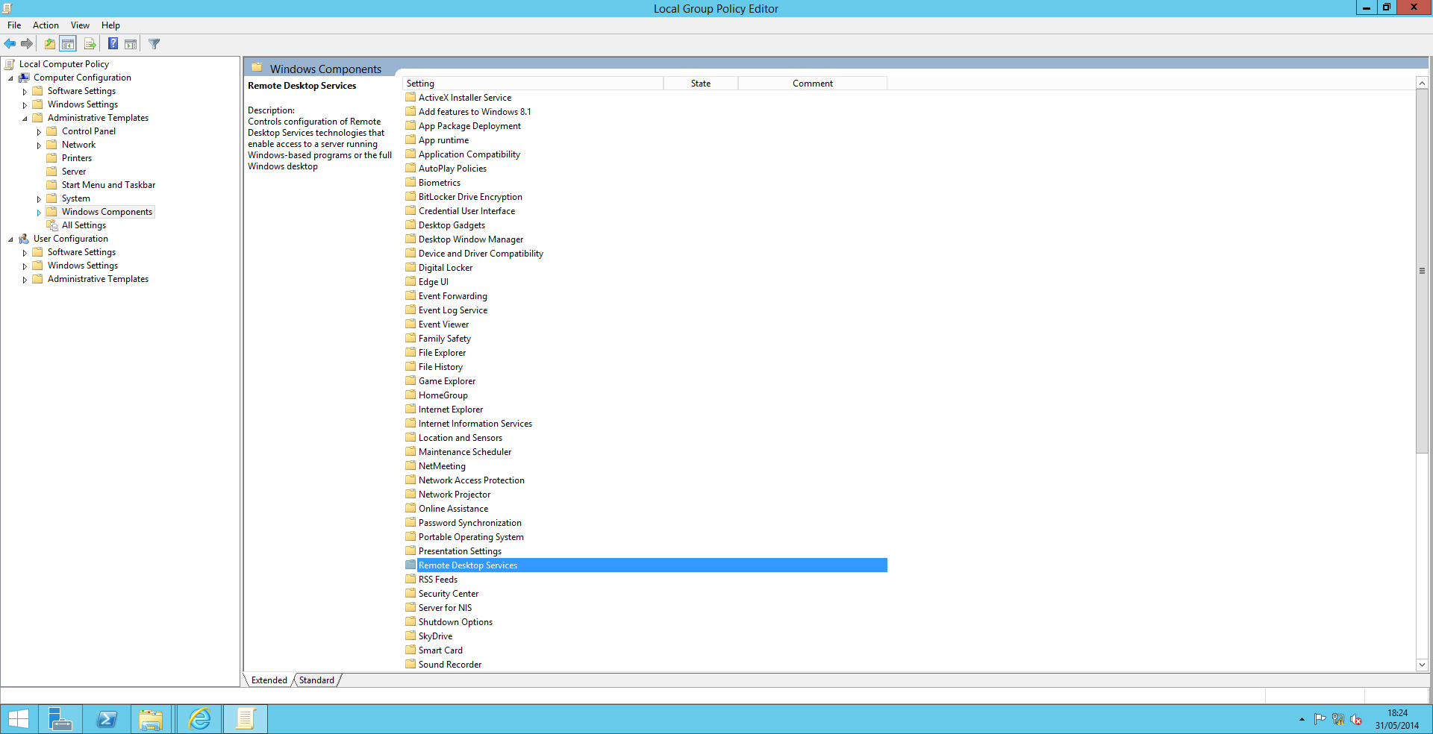 The “Start a program on connection” setting can be found in Computer Configuration-> Administrative Templates-> Windows Components-> Remote Desktop Services-> Remote Desktop Session Host-> Remote Session Environment.
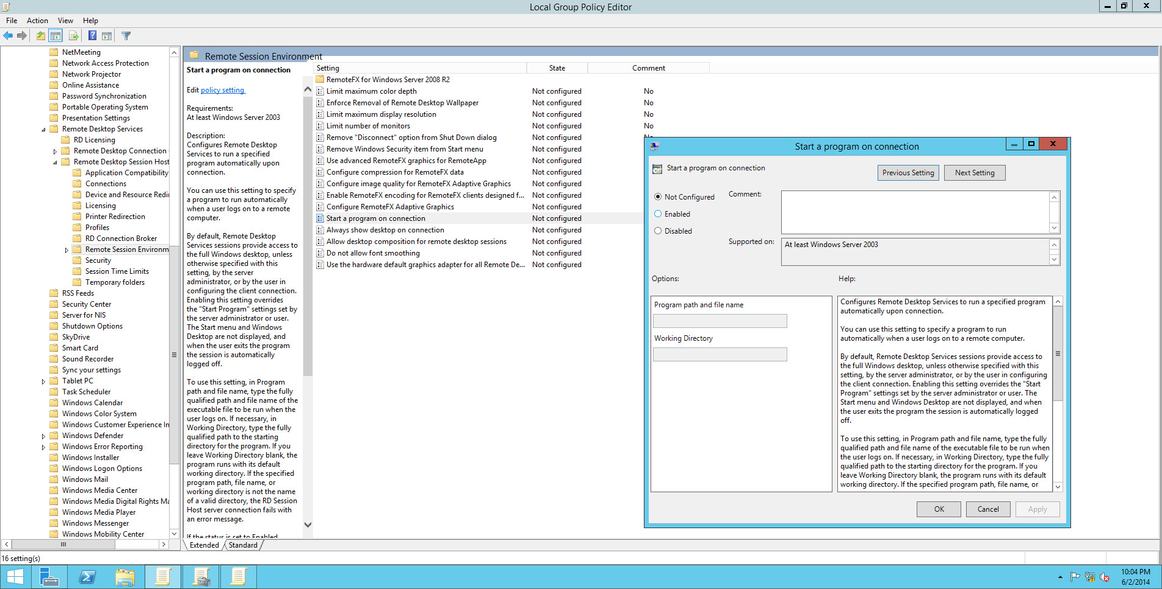
Note : The “Always show desktop on connection” parameter can be used to prevent user to access the desktop
- If you’re in an Active Directory Domain, use the Group Policy Management editor. To open it, go to server manager, click on “Tools” on the upper right, and choose “Group Policy Management”
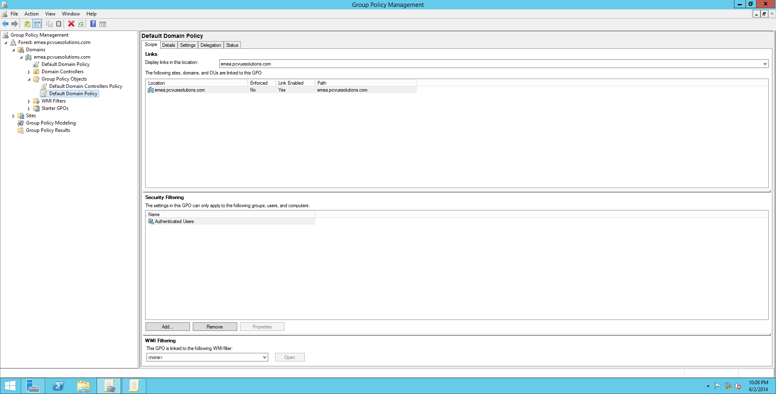
Navigate to “Default Domain Policy”, right-click and select “Edit” (If you are not logged on with administrative privileges, the “edit” is grayed out)
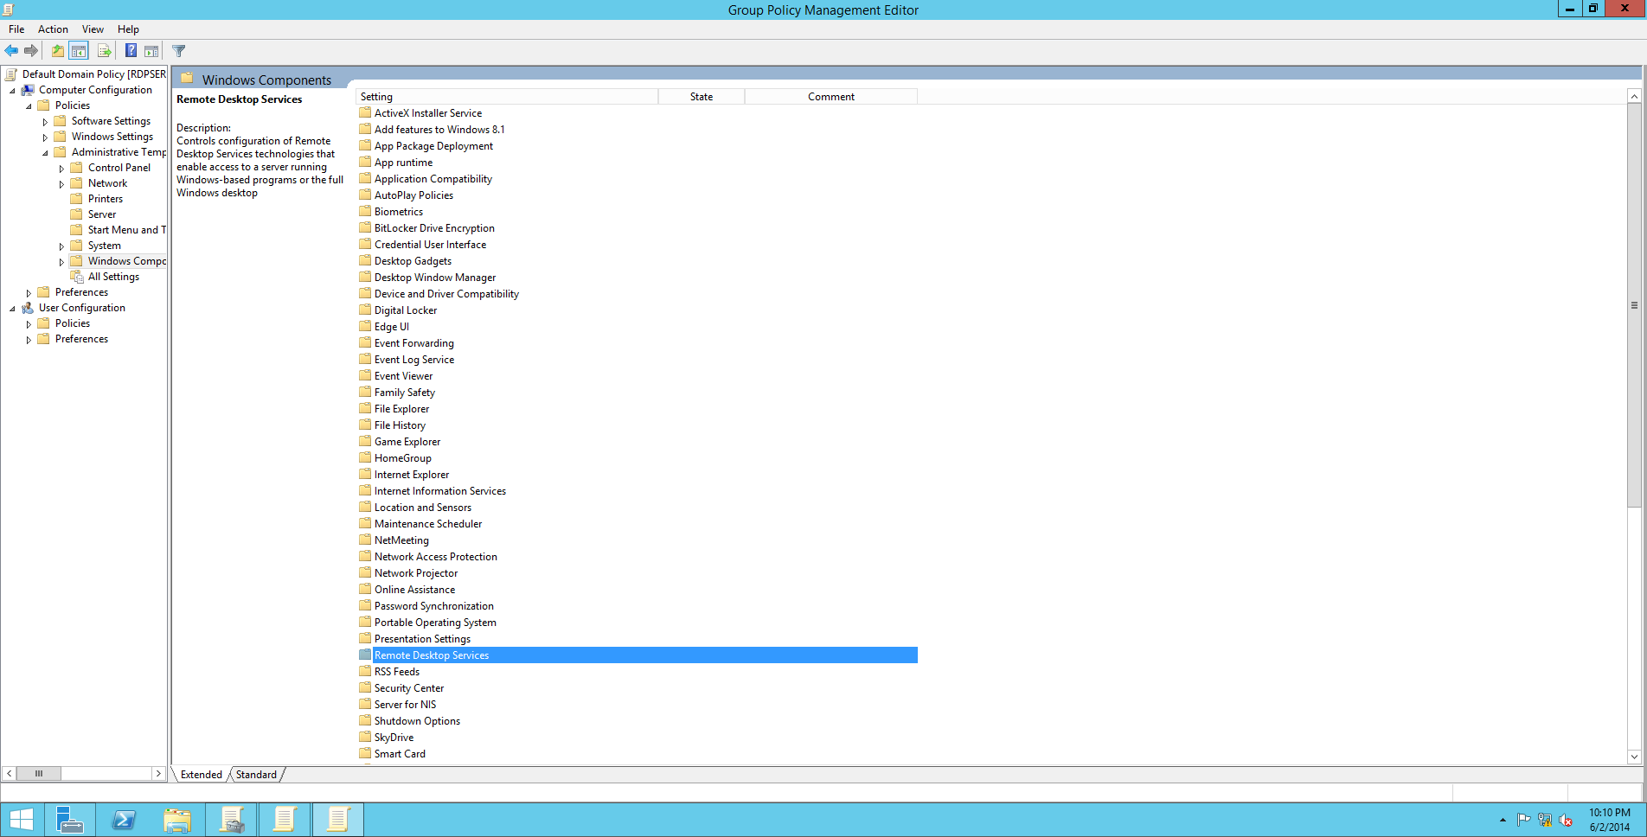
The “Start a program on connection” setting can be found in Computer Configuration-> Administrative Templates-> Windows Components-> Remote Desktop Services-> Remote Desktop Session Host-> Remote Session Environment.

6 – The Remote Desktop Services Licensing manager
There are two types of RDS licenses:
- RDS Per Device CALs
- RDS Per User CALs

Installing the RDLM
If you’re on a server hosting other components of the Remote Desktop Infrastructure, open the server manager, click on the “Remote Desktop Services” item on the left side, and click on the green “+” beside the RD Licensing item
Choose the server on which you intend to install the new feature, click on “next”, “next”. That’s all
If your server doesn’t host any kind of RD Role, you don’t have the “Remote Desktop Services” item. In the Server Manager, click on “manage”, “add roles and features”, “Role-based or feature-based installation» and select the appropriate server.
Select “Remote Desktop Services”, “Next” three times, and check the “Remote Desktop Licensing” checkbox.

Installing the licenses
Open Server Manager, click on “Tools” / Terminal Services, and select “Remote Desktop Licensing Manager”
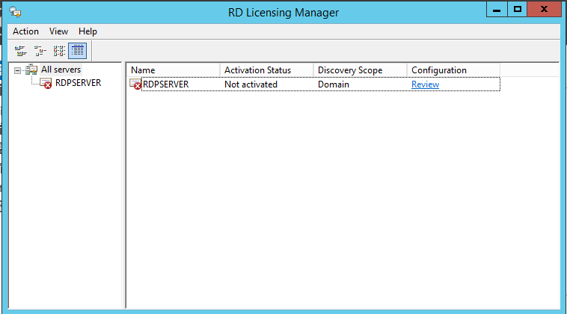
Right-click on the server, and select “activate”
A wizard opens, and you only have to follow it.
Note: In order to activate a License server, you have three choices (no more):
- “Automatic connection”: The server must be able to establish a HTTPS connection to Microsoft’s servers
- “Web browser”: The server cannot access internet, but another computer can
- “By phone”: No web connection possible

7 – The unofficial way: Doing it without an Active Directory Domain
According to Microsoft, you cannot install a Remote Desktop Server without an Active Directory Domain.

Here’s how to setup and configure a little RDS server, just like it was under Windows Server 2003 or 2008:
- Open the Server Manager, and launch the Add Roles and Features Wizard.
- Select Role-based or feature-based installation, and select the Remote Desktop Services Role. Check the following Role Services:
  - Remote Desktop Session Host
  - Remote Desktop Web Access
  - Remote Desktop Licensing
- After reboot, you can launch the Remote Desktop Licensing Manager (Server Manager / Tools / Terminal Services) in order to install the Client Access Licenses
- Open a Windows Powershell prompt, and type in the following commands:
  - import-module ServerManager
  - import-module RemoteDesktop
- Launch GPEDIT.MSC. Go to Local Computer Policy / Computer Configuration / Administrative templates / Windows Components / Remote Desktop Services / Remote Desktop Session Host /
- In the Connections Folder, you have to modify the following parameters:
  - Automatic Reconnection : Enabled
  - Allow users to connect remotely by using Remote Desktop Services: Enabled
  - Limit number of connections: Enabled. You have to type in the maximum number of connections you want to allow (999999 = unlimited)
- In the Session Time Limits folder, you have to modify the following parameter:
  - Set time limit for disconnected session: Enabled. Suggested value: 1 day.
- In the Licensing folder, you have to modify the following parameters:
  - Use the specified Remote Desktop license servers: Enabled. You have to provide either the name or the IP address of your license server.
  - Set the Remote Desktop Licensing mode: Enabled. You must specify which license mode you want to use (per user or per device).
WARNING: This parameter is mandatory to make the RD server work
- As seen previously in this document, you can also modify the “Start a program on connection” and the “Always show desktop on connection” parameters in the Remote Session Environment folder
Don’t forget, as you are in a workgroup, to create users which will access the server via RDS, and affect them to the « Remote Desktop Users » group.
In case of trouble, think about the RD Licensing Diagnoser (Server Manager / Tools / Terminal Services), and as always the Windows logs

8 – Glossary

RD Session Host :
A Remote Desktop Session Host (RD Session Host) server is the server that hosts Windows-based programs or the full Windows desktop for Remote Desktop Services clients. Users can connect to an RD Session Host server to run programs, to save files, and to use network resources on that server. Users can access an RD Session Host server by using Remote Desktop Connection or by using RemoteApp.

RD Connection Broker:
Allows users to reconnect to their existing virtual desktops, RemoteApp programs, and session-based desktops. Enables you to evenly distribute the load among RD Session Host servers in a session collection or pooled virtual desktops in a pooled virtual desktop collection.

RD Gateway:
Remote Desktop Gateway (RD Gateway) enables authorized users to connect to virtual desktops, RemoteApp programs, and session-based desktops on an internal corporate network from any Internet-connected device.

RD Web Access:
Remote Desktop Web Access (RD Web Access) enables users to access RemoteApp and Desktop Connection through the Start menu on a computer that is running Windows 8, Windows 7, or through a web browser. RemoteApp and Desktop Connection provides a customized view of RemoteApp programs and session-based desktops in a session collection, and RemoteApp programs and virtual desktops in a virtual desktop collection.

RD Licensing :
Remote Desktop Licensing (RD Licensing) manages the licenses required to connect to a Remote Desktop Session Host server or a virtual desktop. You can use RD Licensing to install, issue, and track the availability of licenses.

