BACnet schedule demo project

Description: Documentation of BACnet schedule demo project

Keywords: PcVue, BACnet, Scheduler, VBA

Last Revision Date: 17 May 2011
ARC Informatique - Head Office address: 2 Avenue de la Cristallerie 92310 SEVRES - FRANCE
Private Limited Company capitalised at 750 000 € - RCS Nanterre B 320 695 356- APE 722 C - SIREN 320 695 356- VAT N° FR 19 320 695 356

Authorization

 | Name | Stamp | Date
Written by | Armin Kaltenbacher |  | 13 May 2011
Checked by | Florent Martin |  | dd month yyyy
Authorized by |  |  | dd month yyyy

PURPOSE OF THIS DOCUMENT
The purpose of this template is to be used for writing various forms of specification:
- Overview studies,
- Design specification,
- HMI specification,
- …

When a new R&D task is to be started, and depending on a decision taken during macro-planning or planning reviews, such a specification can be required.
The exact content can vary greatly from a thorough specification of a new major module to a very light document describing a new SCADA Basic verb or new system variables.

Once the document is validated, all yellow and grey notes can be removed.

Revision history

Revision | Author | Action | Editing | Date | Distribution
1.0a | AK | Creation | FM | 13/05/2011 | Internal

About document versioning
The first edition of a document shall be versioned as 1.0a.
Further editions distributed for checking purpose shall be versioned 1.0b, 1.0c, 1.0d…
Once validated, the first approved edition shall be versioned 1.0.

Any further editions, corresponding to a minor update shall be versioned 1.1a (resp. 2.0a for a major update), then b, c, d … until a new approved version appears as 1.1 (resp. 2.0 for a major update).

The information in this book is subject to change without notice and does not represent a commitment on the part of the publisher. The software described in this book is furnished under a license agreement and may only be used or copied in accordance with the terms of that agreement. It is against the law to copy software on any media except as specifically allowed in the license agreement. No part of this manual may be reproduced or transmitted in any form or by any means without the express permission of the publisher. The author and publisher make no representation or warranties of any kind with regard to the completeness or accuracy of the contents herein and accept no liability of any kind including but not limited to performance, merchantability, fitness for any particular purpose, or any losses or damages of any kind caused or alleged to be caused directly or indirectly from this book. In particular, the information contained in this book does not substitute to the instructions from the products’ vendor.

All product names and trademarks mentioned in this document belong to their respective owner

SUMMARY

1 Introduction 5
2 Step-by-step 5
2.1 Connect BACnet device 5
2.2 Configure variable 5
2.3 Read schedule 7
2.4 Write schedule 8

Introduction

Note to Author:
This paragraph contains a brief introduction to the document purpose’s and context:
- Its object:
Describes the aim of the document and the potential readers,
- Its field of application:
This paragraph must mention the product and version to which the document is applicable,
- Document description:
A brief abstract of the main sections – Usually level 1 sections.
A brief description of terms used with a particular meaning in the context of the document

The project contains one mimic: SCHEDULER.
The project contains two VBA modules that are to process the encoding and decoding of BACnet schedules.

Event handlers in the ThisProject section that trigger the OnLoad and OnSave (thus it is WebVue compatible!!!).

And the actual code in the class module BacNetSchedule.

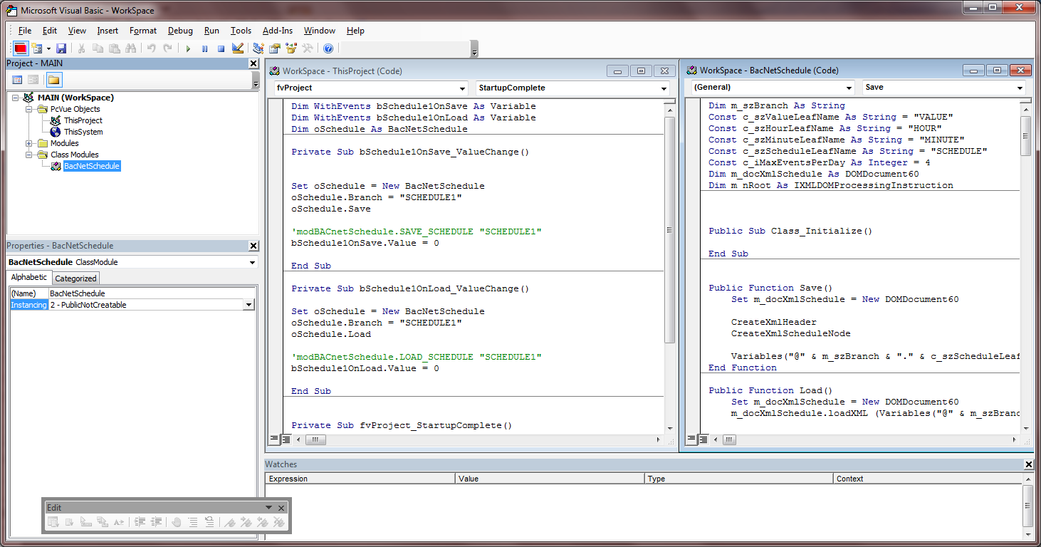

Step-by-step

Connect BACnet device

Connect any available BACnet device with a pre-configured schedule. The schedule has to be a schedule referencing a value of type real.
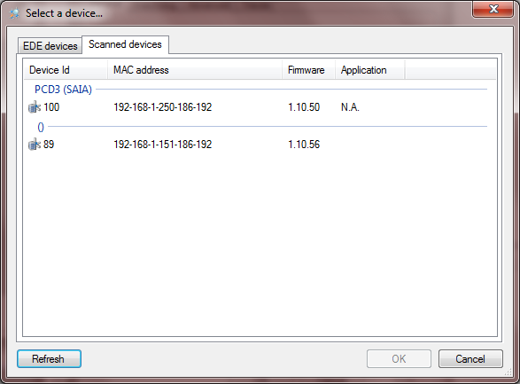

Configure variable

In the project there is a variable called @SCHEDULE1.SCHEDULE_RAW. Connect this one to the schedule of the BACnet device:
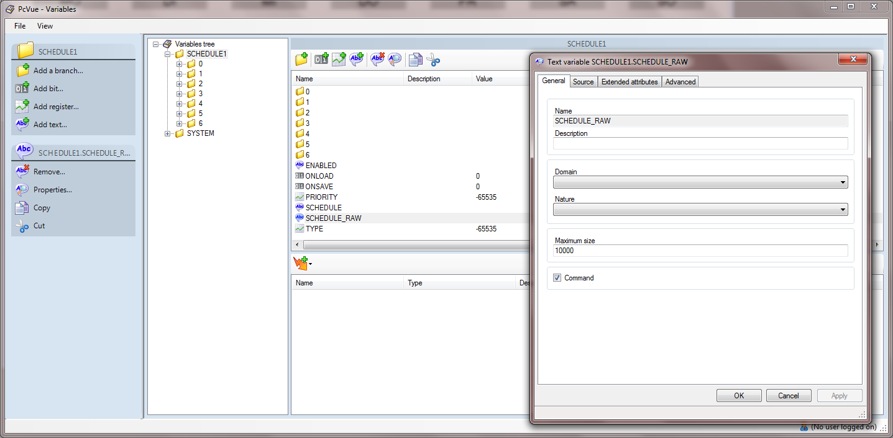

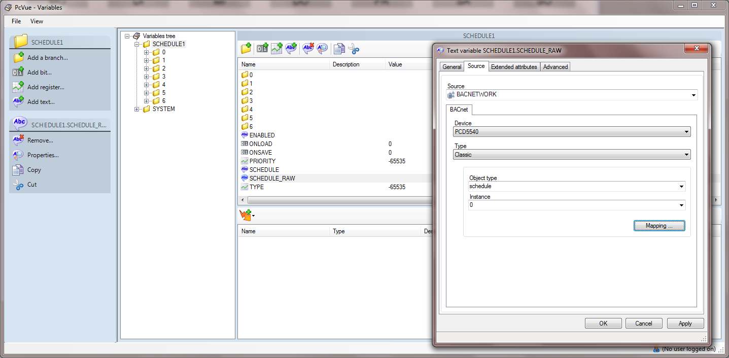

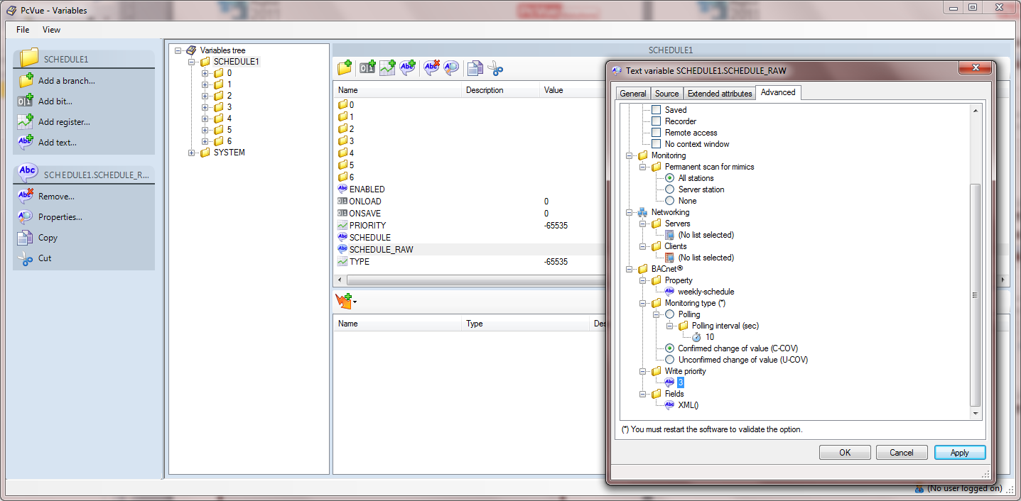

Make sure that you…:
- Select the right object
- Select the right property (weekly-schedule)
- Adjust the monitoring type
- Select a good priority
- Switch to XML() representation

Read schedule

Open the mimic SCHEDULER.
Click “Raw string to internal string”. There are actually two variables carrying the content of the BACnet variable which is in fact for the purpose of debugging.

SCHEDULE_RAW is the variable actually connected to the external source.
SCHEDULE is an internal variable on which is worked.

With “Raw string to internal string” you copy the content of the BACnet variable to the internal variable. If everything is fine you should see the content in the big text field.
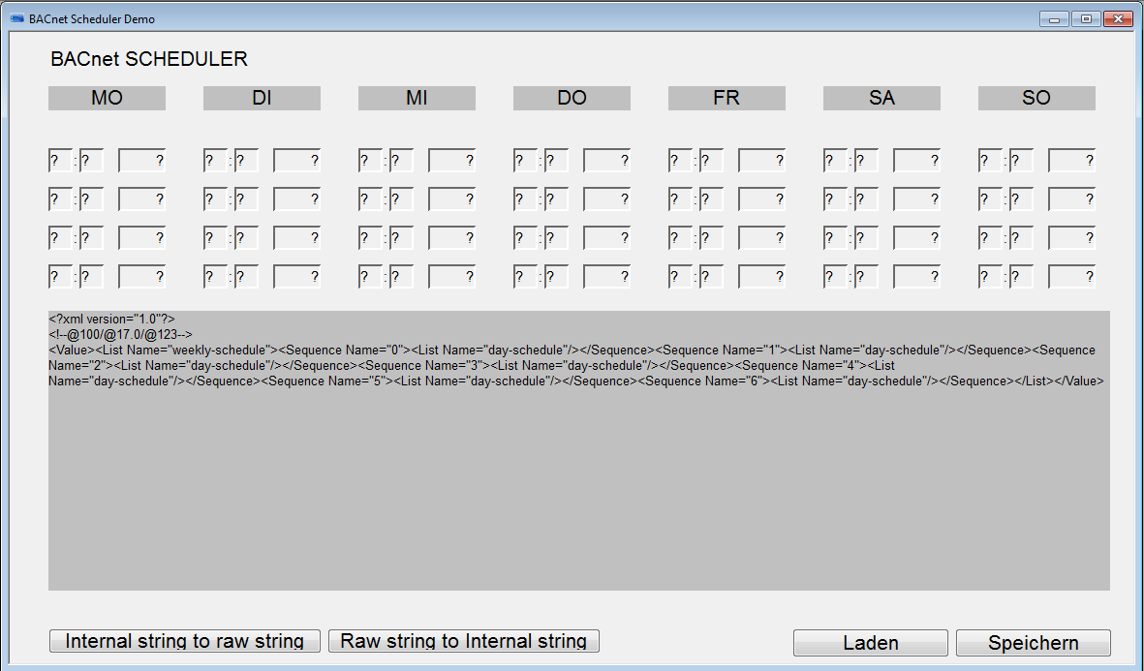
Now click “LOAD” and the content of the variable is analyzed and put into the fields of the weekly schedule.

The schedule in the screenshot above is empty.

Write schedule

If you want to write the schedule to the controller just edit the times however you want. Currently only real (register) values are supported. Of course it would be simple to also make a mimic for binary schedules.

Then press SAVE and “Internal string to RAW string”…:

