Archives Settings
The archives settings can be displayed from the Archives folder in the Application Explorer's Main settings dialog or by using the Settings task when the Archives is selected in the Application Explorer's configuration tree. Show picture
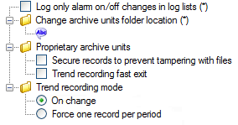
- Log only log alarm on/off changes in log lists - Selecting this property causes the acknowledged condition of an alarm to be ignored - see explanation below.
- Change archive units folder location - Enter an alternative location for the Supervisor's archive units. (The default location is in the TH folder of the project.) Any location you enter must be always available. The ellipsis button, displayed when clicking in the text field, opens a Browse Folder dialog that can be used to select the path and folder.
- Proprietary archive units
  - Secure records to prevent tampering - Adds a CRC (Cyclic Redundancy Check) to proprietary format archive units to protect the data from being tampered with.
  - Trend recording fast exit - Reduces the time taken to flush the trend recording buffers to hard disk on shutdown by writing all the data in one shot. The disadvantage of this method is that it is more prone to data loss should there be any problems during shutdown.
- Trend recording mode
  - On change - Enable on-change (exception) trend recording. The trend Period property is used as a time filter. Applies to the entire project.
  - Force one record per period - Enable periodic trend recording. The trend Period property is used as a sampling period. Applies to the entire project.
Using the Only log alarm on/off changes property
Selecting this property causes the acknowledged condition of an alarm to be ignored as follows.
Alarm state | Logged as
On, On - Not Ack. and On - Ack | On
Off and Off - Not Ack. | Off
Unavailable | Unavailable
Selecting this property changes the behavior of the Log Viewer and the appearance of the log list Event Filter tab but it does not change the operation of the Alarm Viewer.
The Supervisor must be restarted after changing this property before it takes effect.

Important Note About Trend Recording in Version 11
Up until version 11, all trend recording was on-change (exception) driven with the option of a filter period.
From version 11 onwards the period can be used either as an on-change filter (as before), or as a periodic recording period. See the archives Settings topic.
For further information about how the period is used see the topic, Understanding the trend period for more information.

Configuring a Trend Group
A Trend Group is used to configure the recording properties, for one or more variables, when recorded in a database archive unit. The properties must be given careful consideration to make sure variables are only recorded when necessary. Recording variables more often that necessary by using too small a Period or Deadband can rapidly fill a database.
How to configure a trend group for exception recording
- Open the Application Explorer and expand the configuration tree to select the Trend Group folder.
- From the task list select Add a trend group.
- In the Name field enter a name by which the Trend Group will be known. You can enter an optional comment in the Description field.
- Tick the Set as default tick box if the trend group is to be used as the default. The Set as default tick box is only available if you have created two or more trend groups.
- Enter the Period for the group in hours, minutes, seconds and milliseconds. The minimum is 0 seconds and the maximum 100 hours. See the topic Understanding the trend period for a detailed explanation of how the trend period works.
- Enter the Deadband for the group as a percentage.
- Click the OK button to confirm the configuration and close the dialog.
Show picture
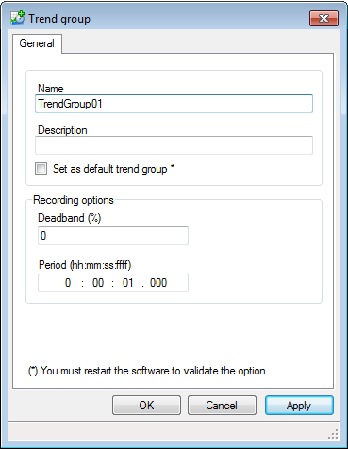
If the minimum update rate of 0 seconds is used, the value of all variables allocated to that group will be recorded every time they change.

While the Deadband is optional it is recommended that it is always used. When measuring analogue values digitally there is always a small variation in the measured value, even if the process value is steady, due to the way in which analogue to digital converters work.

There can be one, and only one, Trend Group with the property Set as default ticked.

Understanding How the Trend Period Affects Recording
The trend period referred to in this topic appears in both the Trend Group dialog (Database Archive Unit) and in the Trend dialog (Proprietary Archive Unit). Show picture
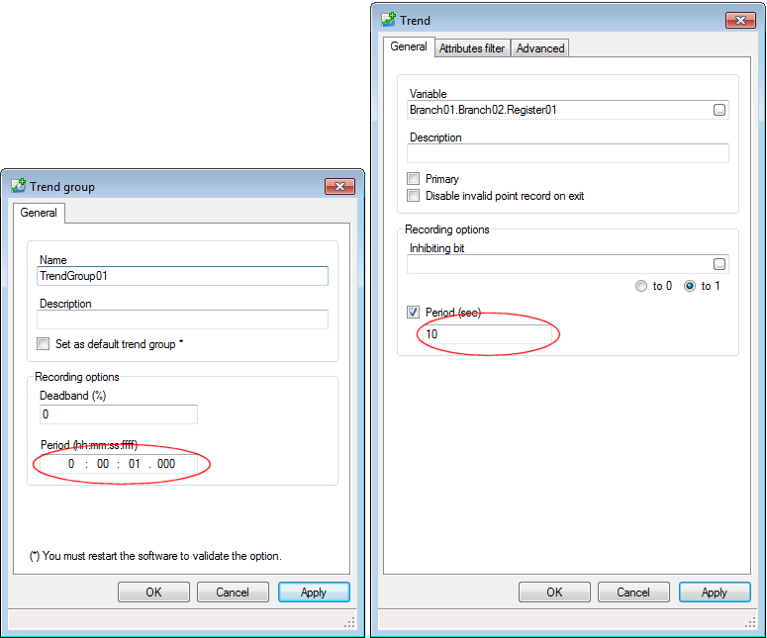
Version 11.0 of the Supervisor allows the choice of on-change trend recording or periodic recording. The choice is made in the Archives Settings dialog and applies to the entire project. This topic explains the exact behavior of the two methods.
To illustrate the behavior the following variable values plotted against time are used. The Period is set to 10 seconds.
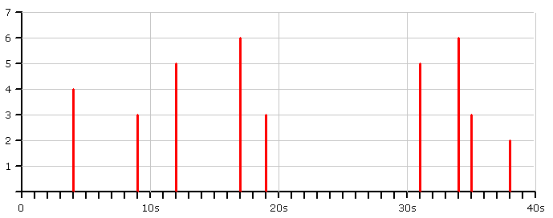
On startup, if the station does not belong to a Historical server association, an invalid point with a time-stamp of the startup, is always recorded.
On-change recording
This was the only option available prior to version 11 of the Supervisor.
- If the value, timestamp, or quality of the variable does not change during the Period, nothing is recorded.
- If the value, timestamp or quality of the variable changes during the period, the most recent value is recorded along with the time at the end of the period.
Value of 3 is recorded with a timestamp of hh:mm: 10
Value of 3 is recorded with a timestamp of hh:mm: 20
Value of 2 is recorded with a timestamp of hh:mm: 40
- If the value, timestamp or quality of the variable changes during the period, and the source of the variable's value is a time-stamped protocol (BACnet, OPC etc.), the most recent value is recorded along with the time-stamp at which it changed.
Value of 3 is recorded with a timestamp of hh:mm: 09
Value of 3 is recorded with a timestamp of hh:mm: 19
Value of 2 is recorded with a timestamp of hh:mm: 38
Periodic (One record per period) recording
This is a new option introduced in version 11 of the Supervisor.
- The value of the variable and the time is recorded at the end of each period. This behavior is irrespective of the source of the variable.
Value of 3 is recorded with a timestamp of hh:mm: 10
Value of 3 is recorded with a timestamp of hh:mm: 20
Value of 3 is recorded with a timestamp of hh:mm: 30
Value of 2 is recorded with a timestamp of hh:mm: 40
If the Period is set to 0
- If the period is set to 0 the value of the variable, and the time-stamp, is recorded every time that the value, time-stamp or quality changes irrespective of which recording mode is selected.
Value of 4 is recorded with a timestamp of hh:mm: 04
Value of 3 is recorded with a timestamp of hh:mm: 09
Value of 5 is recorded with a timestamp of hh:mm: 12
Value of 6 is recorded with a timestamp of hh:mm: 17
Etc.

Adding a Variable to a Proprietary Archive Unit Trends Folder
How to add a variable to a Trends folder
- Open the Application Explorer and expand the configuration tree to display a previously configured archive unit folder and select its Trends folder.
- In the task list select Add a trend. The Trend Configuration dialog opens. Show picture
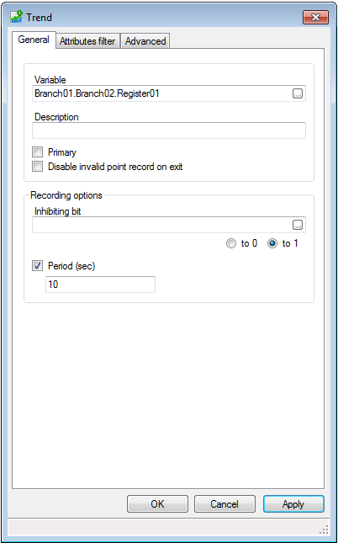
- Enter the name of the variable to be added to the Trends folder in the Variable text box. You can either type in the name or select it from the Variable Browser displayed by clicking the ellipsis button adjacent to the text box.
- Enter an optional description in the Description text box.
- By default the value of the variable will be recorded each time that it changes. To change this tick the Period tick box and enter a Period value in seconds. See the topic Understanding the trend period for more information.
- Click OK to confirm the configuration and close the dialog.
Deleting a trend
- Open the Application Explorer and expand the configuration tree to display a previously configured archive unit folder and select its Trends folder.
- In the right pane select the trend to be deleted.
- From the task list select Remove and then confirm the action by clicking the OK button.

